**SAP Business Object Design Studio 1.5**

**Exercise: Integration of SAP HANA with SAP Business Object Design Studio.**

Student Name: Nupur Ray

Student Net Id: nxr163130

HANA Login Id: GBI_345

Date: **21/10/2016**

**Note**: You must use the following convention to name objects/systems created in this exercise:

Replace XXX with your 3 digit HANA ID (the 3 digit number in your SAP HANA username GBI_**XXX**).

Please use the screenshots **ONLY** as a reference. The instructions have to be followed AS written.

**Objective:** The exercise is designed to help students to:

* Get introduced to the various features of SAP Business Objects Design Studio.
* Create reports/dashboards using Design Studio on the Analytical views built in SAP HANA in previous exercise.

To connect SAP Business Objects Design Studio with SAP HANA, you need ODBC connection drivers. These are in-built in SAP HANA Client and hence this assignment includes installation of SAP HANA Client along with SAP Business Objects Design Studio.

**Part I: Installation of SAP HANA Client.**

SAP HANA Client contains the database drivers needed to communicate with the SAP HANA Appliance. Please follow these steps to install the software. *(NOTE: Not all screenshots are shown)*

1. Extract SAP HANA client archive to a directory on your PC and then double-click on *hdbsetup.exe*.

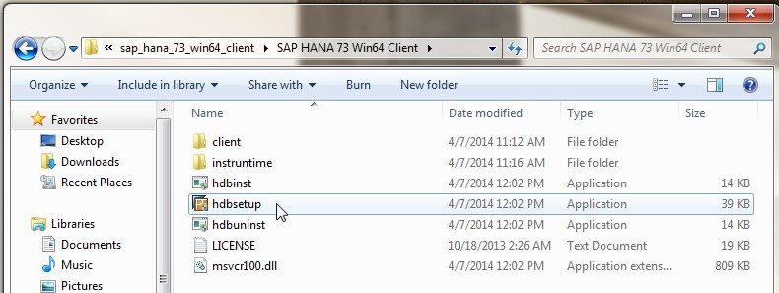

1. Select *Install new SAP HANA Database Client*.

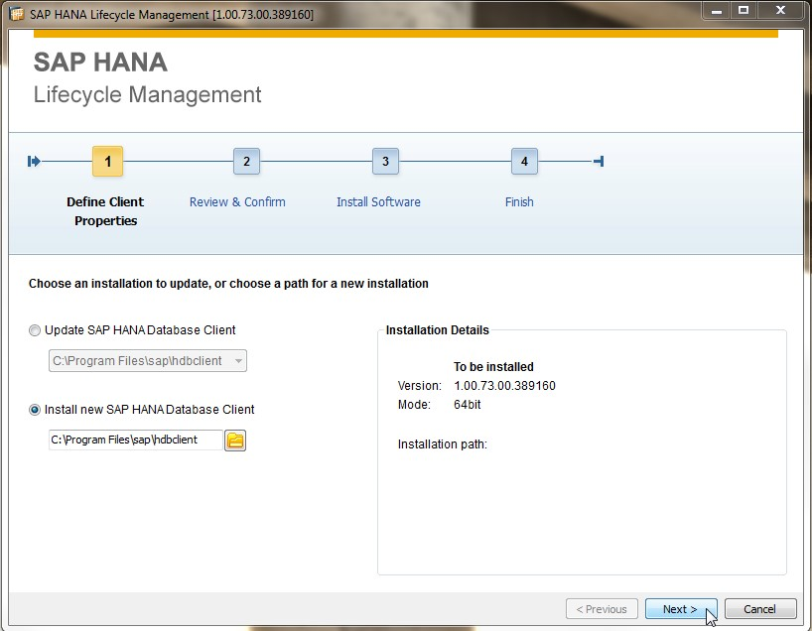

1. Click on *Install* and you can see the following screen:

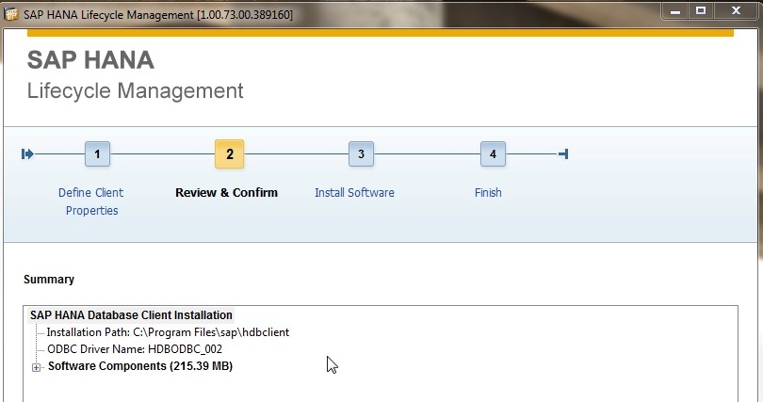

1. The installation should complete successfully.

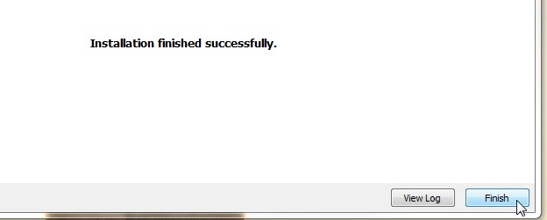

**Part II: Installation of SAP Business Objects Design Studio.**

1. Download the SAP Business Objects Design Studio Client set-up from e-learning.
2. Run the Design Studio Client set-up exe. (Pease note that this may take several minutes, so please wait patiently.)

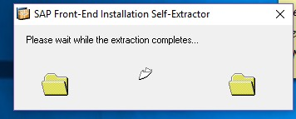

1. Windows security alert may pop-up asking for permission to modify the contents of the hard-disk. You may want to grant permission for the installation to proceed.

Click on *Next.*

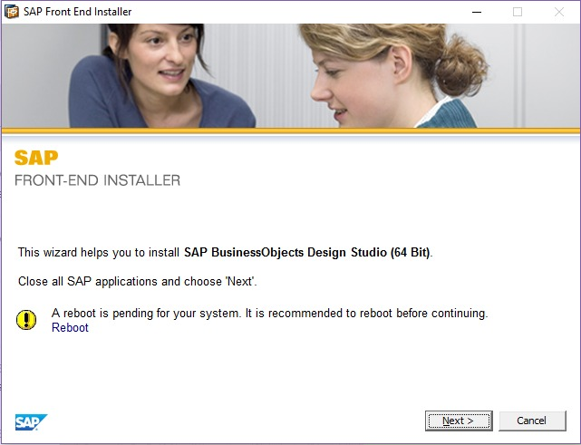

1. Check the check box as shown and click on *Next*.

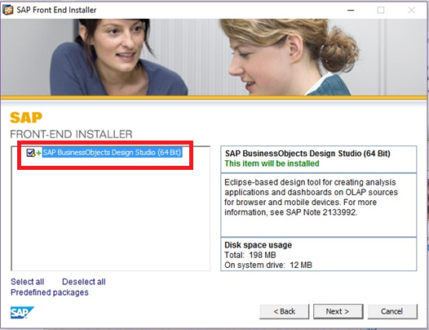

1. Select a path of your choice or create directories for the files to install and click on *Next.*

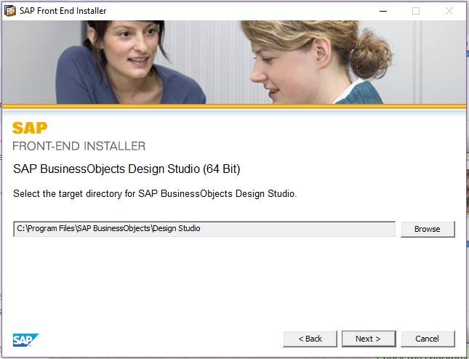

The installation may take some time, so please be patient.

1. At this time, you need to reboot the system.

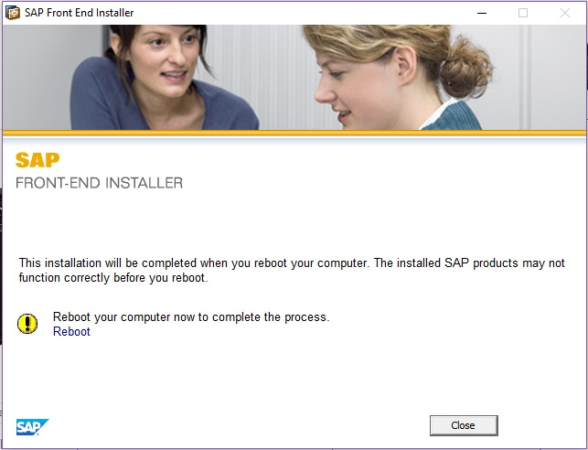

1. Once you have restarted the machine, go to

Start -> All Programs -> SAP Business Intelligence -> Design Studio.

Design Studio opens up with a Welcome tab (shown below) that provides access to useful links, recently used Applications and a button to create a new Analysis Application.

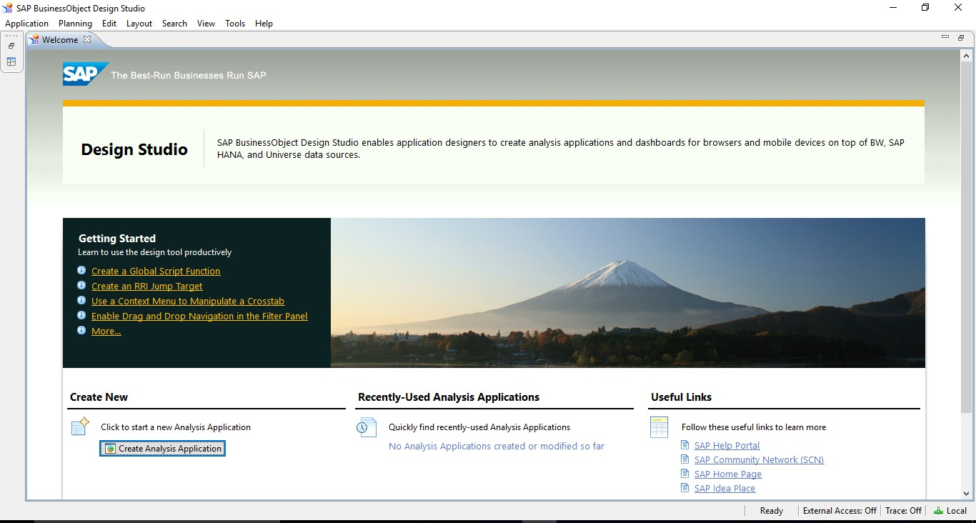

1. If you close the Welcome tab, the main Design Studio interface opens up. A screenshot of the same is given below.

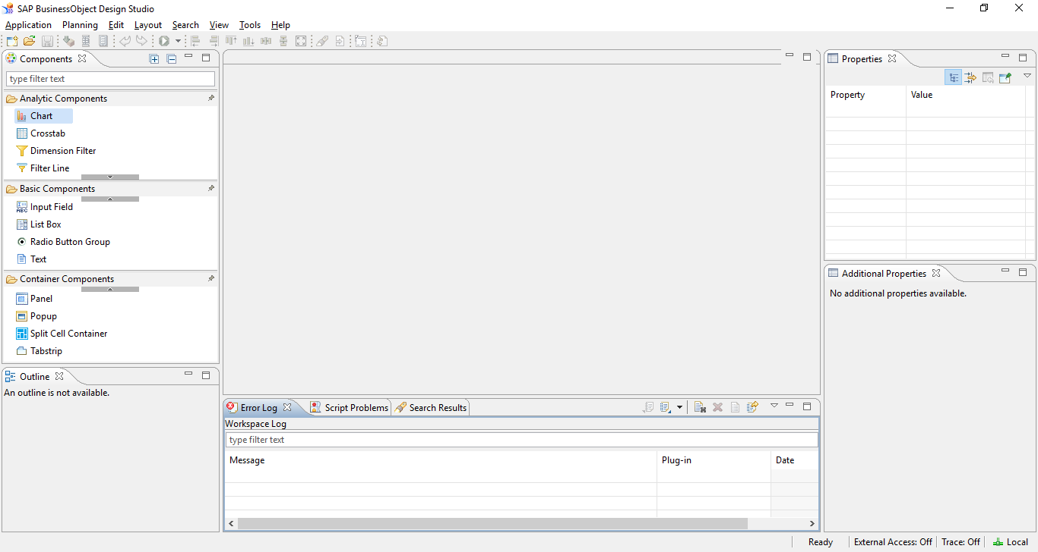

**Part III: Connecting SAP HANA to SAP Design Studio.**

1. Go to *Tools* option -> Click on *Preferences.*

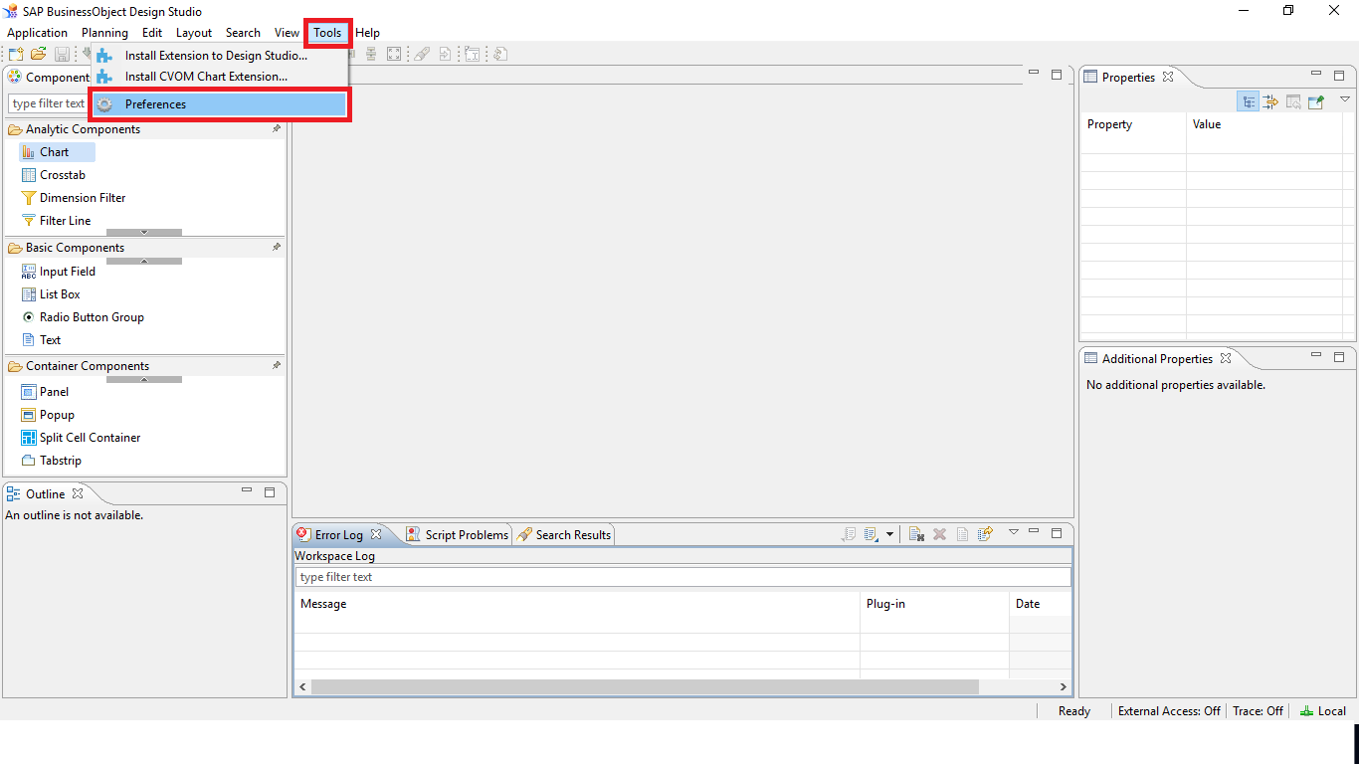

1. Within *Application Design,* click on *Backend Connections.*

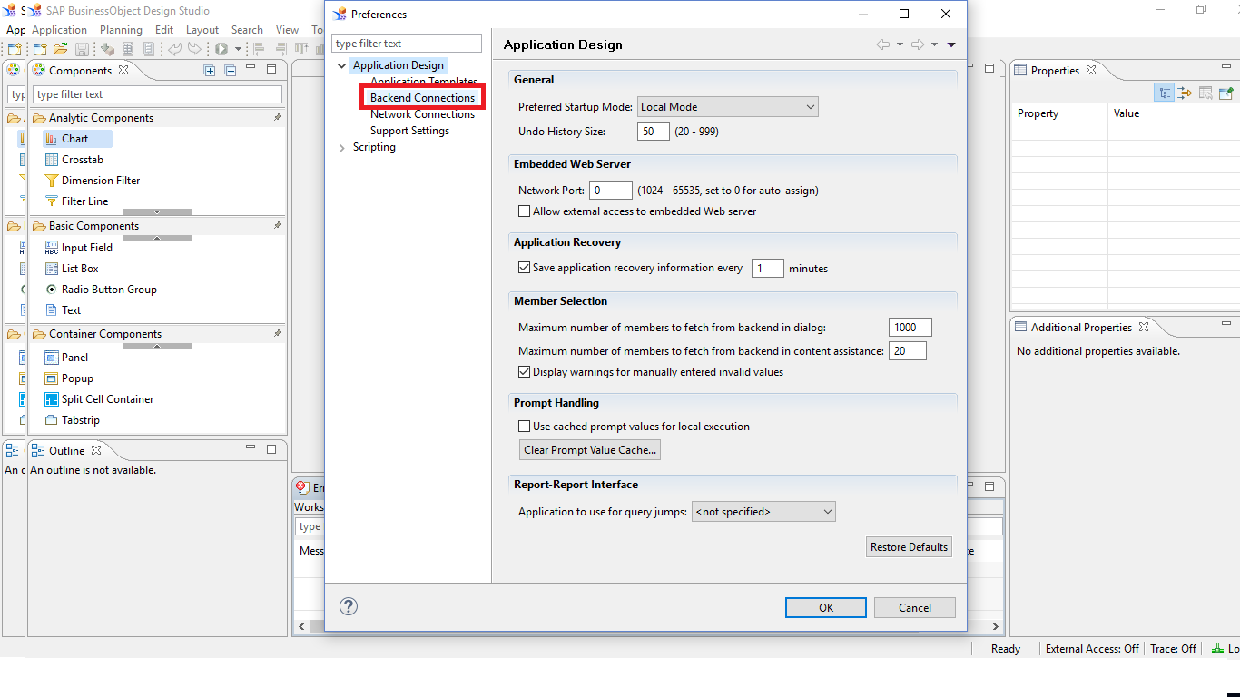

1. Now we are going to setup an SAP HANA ODBC connection to connect to SAP HANA.

Click on the little gear icon that is highlighted by a red box in the below screenshot.

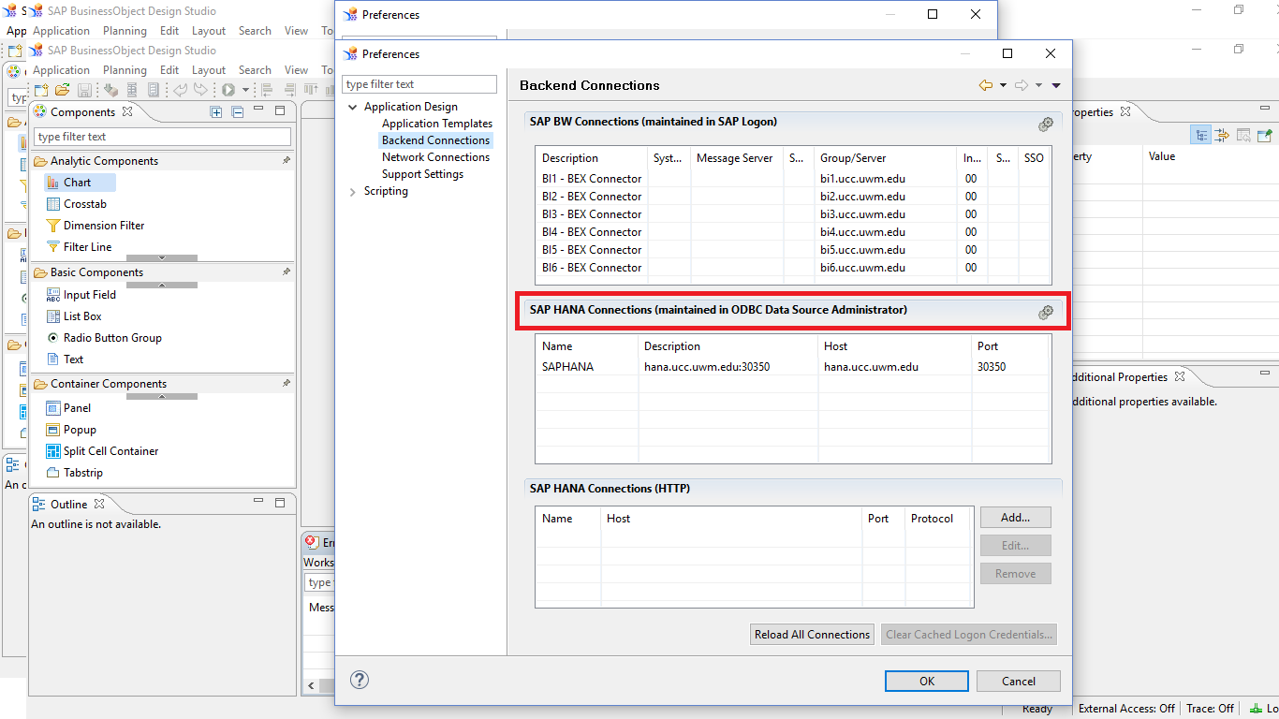

1. Click on *System DSN*’ tab -> Click on *Add*.

A window with a list of drivers will come up as shown. Select ***HDBODBC*** driver and click on *Finish*.

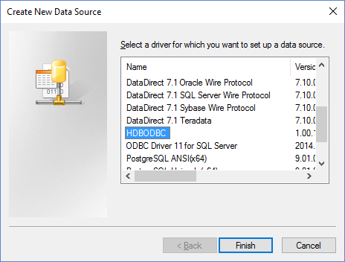

1. Now, we need to fill in the Data Source Name details as described in the screenshot. Enter Data Source Name as ‘**SAPHANA**’ and use the Server:Port string as “**HANA.ucc.uwm.edu:30359**”.

We will now test the connection by clicking on *Connect.*

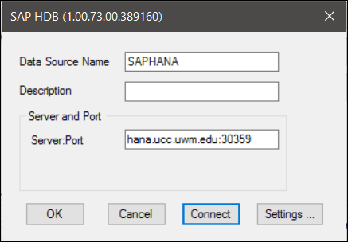

1. After clicking on *Connect*, enter your SAP HANA username and password. (Please refer to the class roster on e-learning for the credentials.)

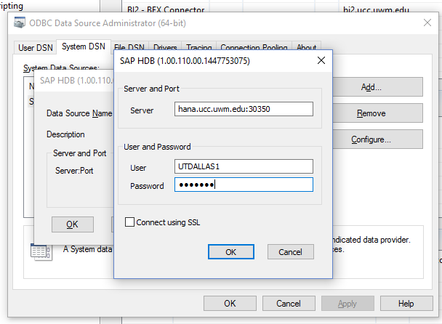

1. Click on *OK*. You should be able to connect to SAP HANA successfully as the message shown below.

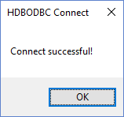

1. Click on *OK*, and then click on *OK* again.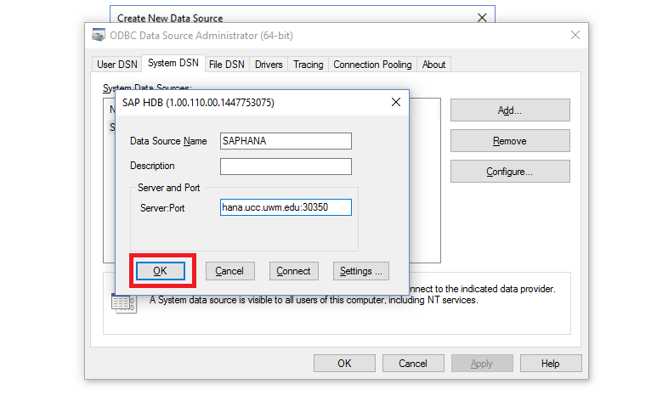
2. Now you can see the connection under System DSN tab. Click on *OK.*

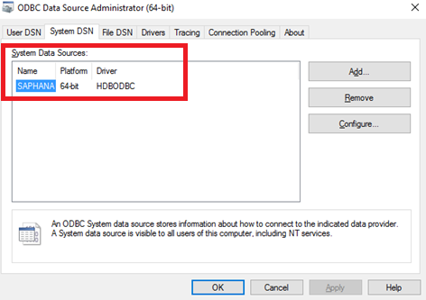

1. You can also see the connection details in SAP HANA Connections. Now that the connection is created successfully, you would have to reload the connection to be able to see it while adding a Data Source into an Application.

Click on ‘*Reload All Connections*’ and then click on *OK.*

Note: It may ask you to restart the design studio and while restarting, it asks for your SAP HANA credentials.

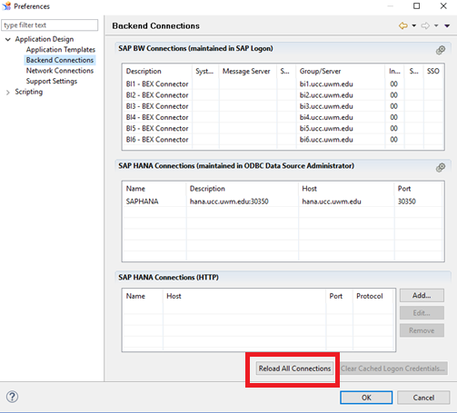

We have successfully connected SAP Design Studio to SAP HANA.

**Part IV: Creating an Analysis Application in SAP Design Studio.**

To create a New Application,

1. Click on *Application* -> click on *New* in the design tool menu option. Alternatively, you can click on the left most icon on the tool bar.

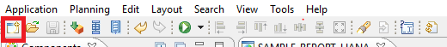

1. The New Application dialog box will be displayed.

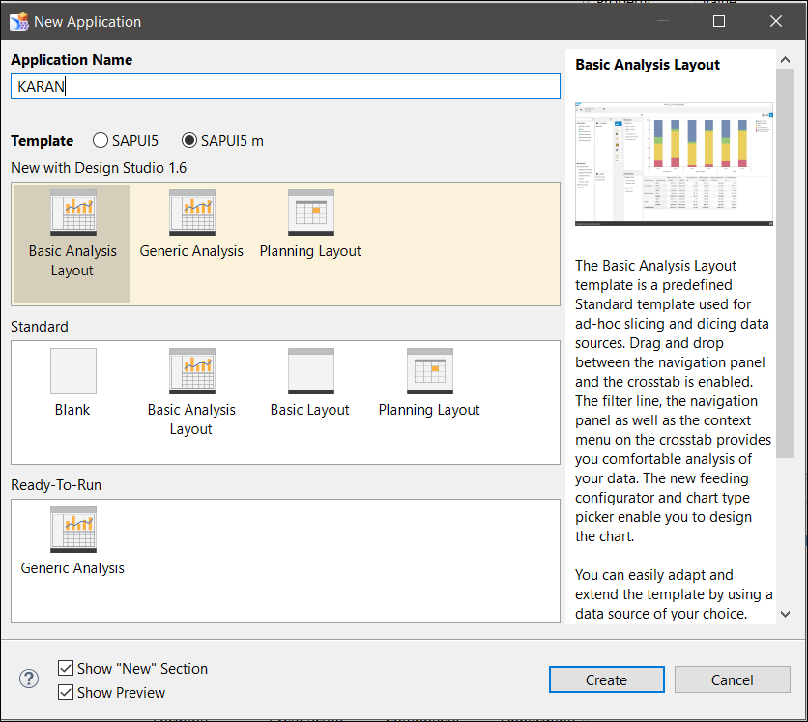

1. Enter Name of the Application as ‘**HANA_REPORT_GBIXXX**’ and select Blank under “Standard” then click on *Create*. Application will open as shown below.

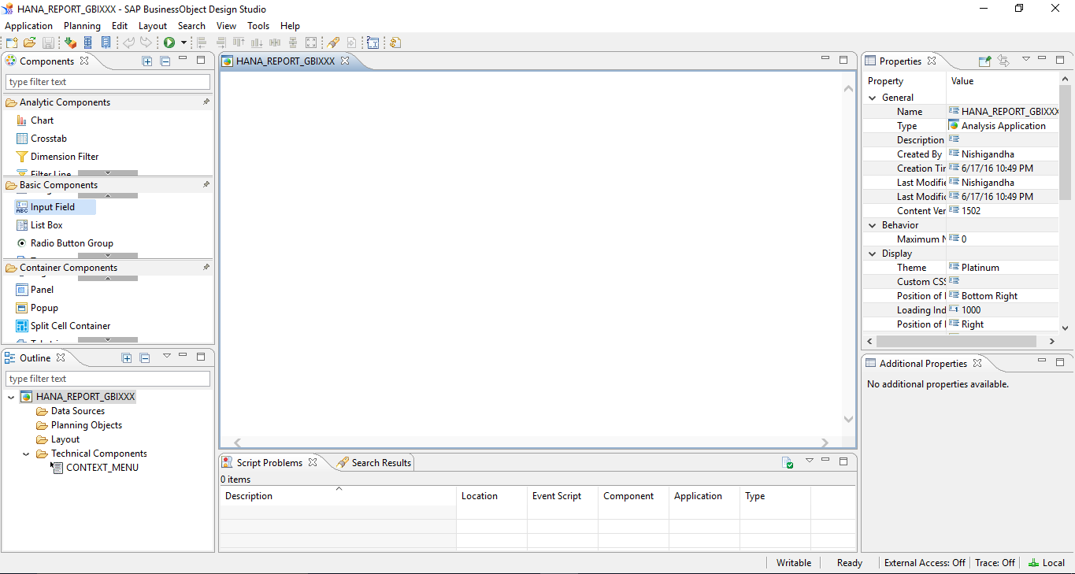

2. After creating an Application, the first step is to add a Data Source to the Application.

a. To do this, click on *Application* -> click on *Add Data Source.*

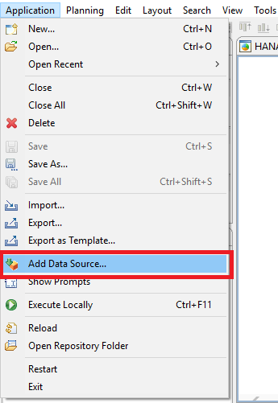

Alternatively, you may right click on the Data Sources folder under your Application name (HANA_REPORT_GBIXX) in the Outline pane and clink on *Add Data Source.*

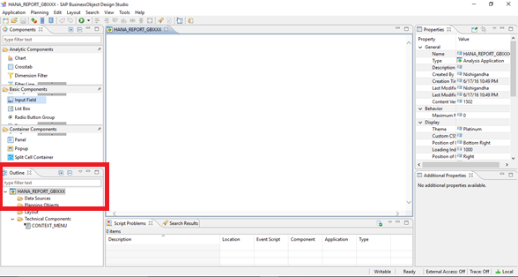

b. Click on *Browse* for Connections.

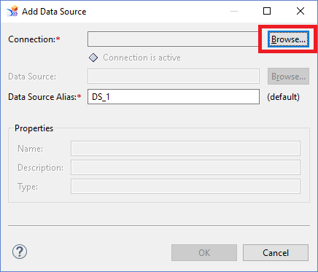

1. Once you click on Browse, you will see the below screen having a list of connectors. Select the SAP HANA connection **SAPHANA** that we created in Part III of this assignment and then click on OK.

Note: You may be asked to enter your SAP HANA username and password to connect to SAP HANA. If so, then please enter the credentials and then proceed.

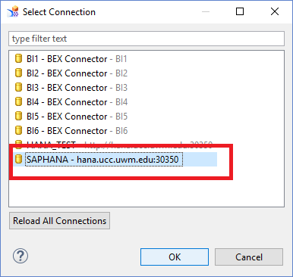

1. You can now see the green little box showing that the connection is active. Now click on *Browse* for Data Source.

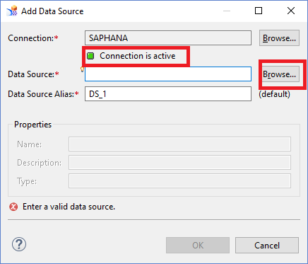

1. You will see all the database schemas of SAP HANA in the Folders tab. (This is similar to what you see in SAP HANA Design Studio.)

Select and expand your schema folder GBI_XXX -> Select the Analytical view (**SALES_AV_YYY**) that you had created in SAP HANA Modelling exercise.

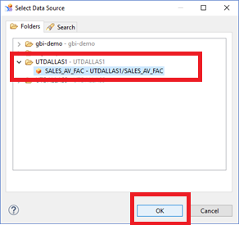

1. Once you have added the Connection and Data Source, Click on *OK.*

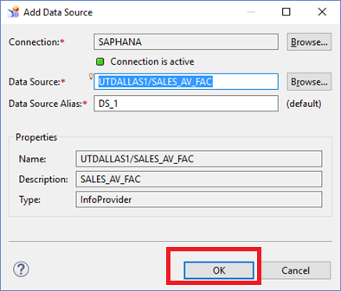

1. And now you can see the Analytical view added in the Data Source folder of the Outline pane.

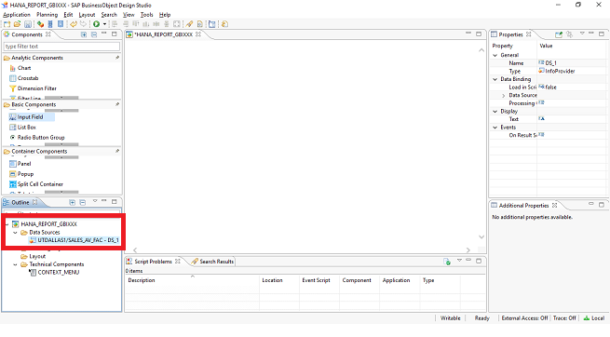

1. Now that we have created an Application and added a Data Source to it, the next step is to use some reporting components and create a dashboard.
2. Drag and drop **InfoChart** from **Analytic Components** on to the canvas. Click on the bottom right corner to resize the component.

To assign a Data Source to a component, drag and drop the Data Source onto the component. Alternatively, you may go to the Properties pane on the right hand side and define the Data Source by selecting it from the dropdown list as shown below.

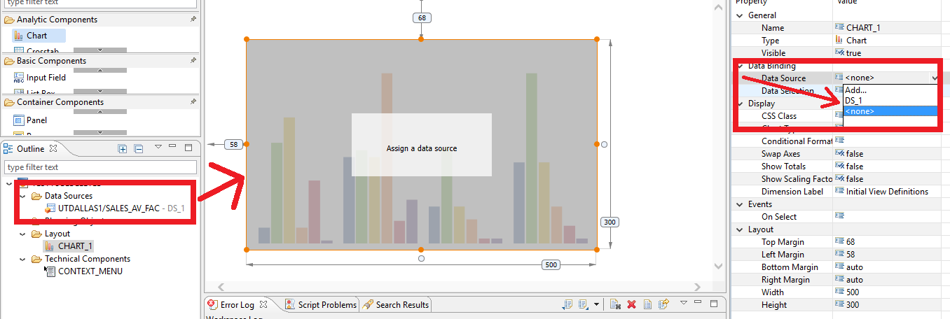

1. Drag and drop **Crosstab** from **Analytic Components** on to the canvas. Bind this Crosstab to the Data Source, the same way you did for Chart in the previous step.

Now your canvas has two components; a Chart and a Crosstab as shown below.

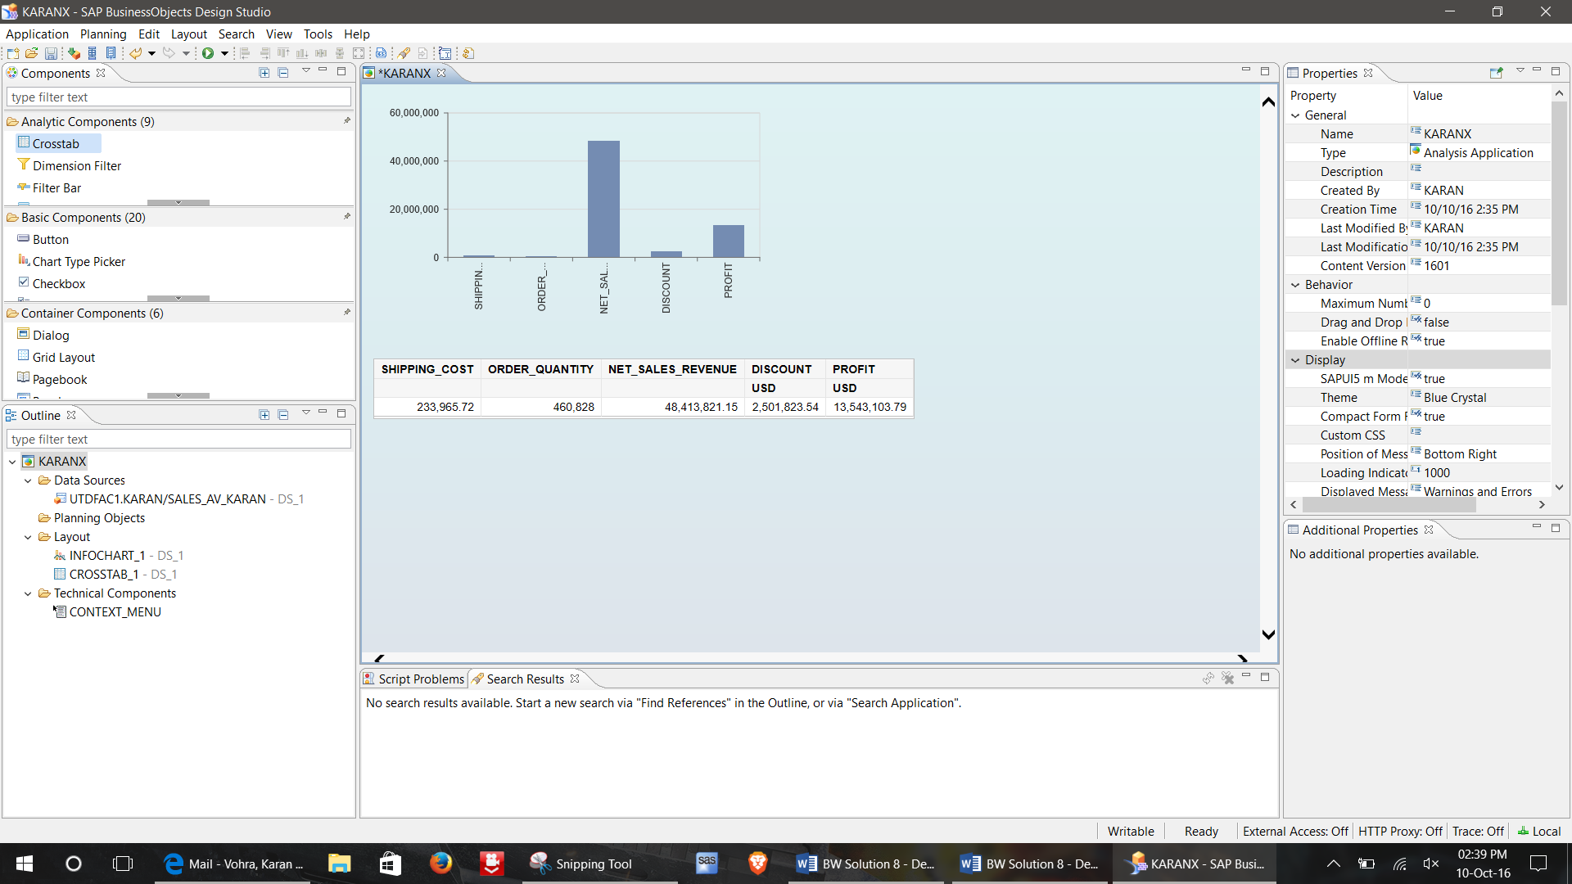

1. Save the Application (CTRL+S or click on  ) and execute it by clicking the icon .

**Paste the screenshot of the Output here:**

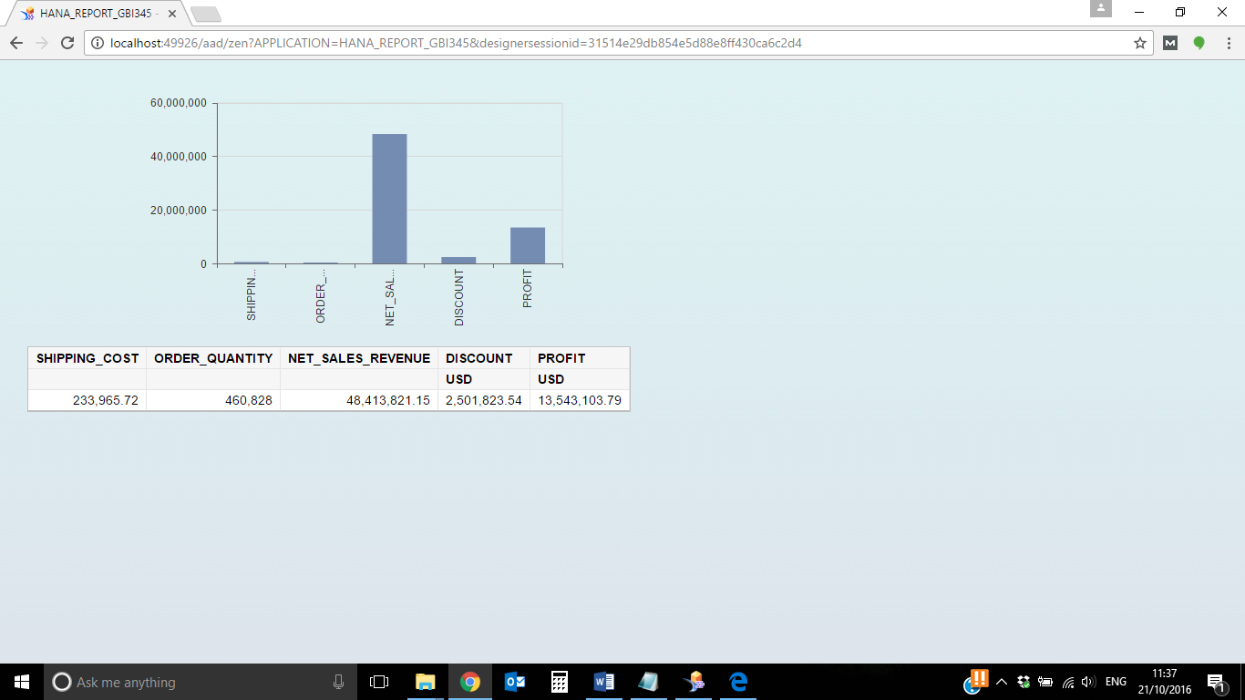

1. When you assign a Data Source to a component, a default query gets generated and as a result of this you can see the numbers/figures on the component. Let us go ahead and make some changes to the query. To do this, go to the Data Source (Outline pane), right click on it and choose *Edit Initial View* option.

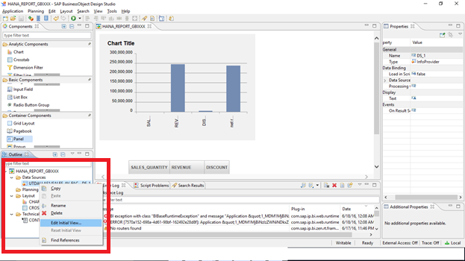

1. The initial view of the Data Source looks like the screenshot below.

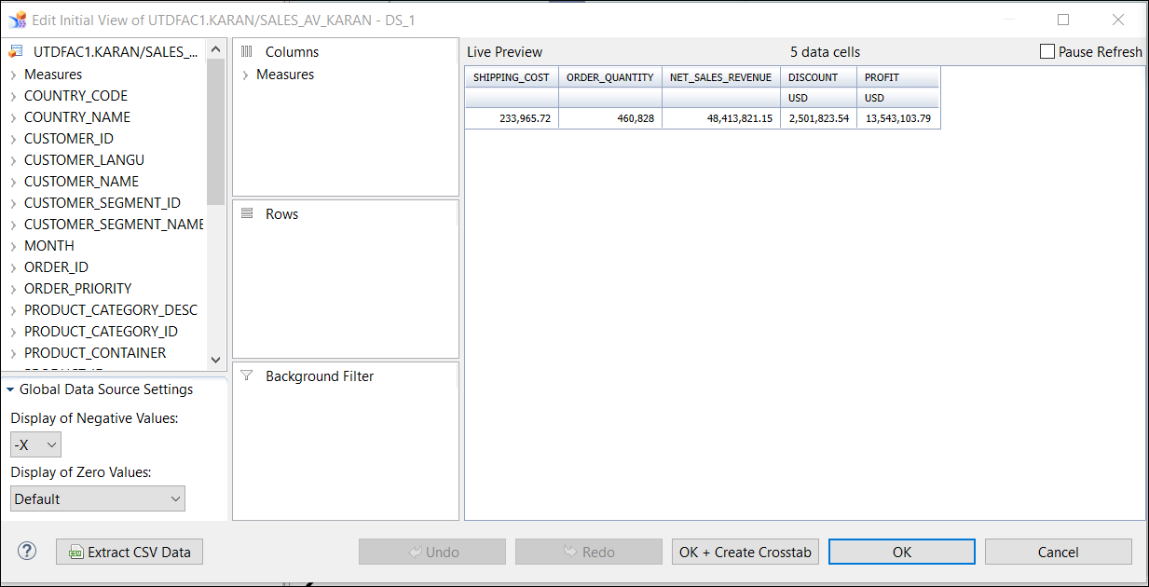

1. On the left is the list of all dimensions and measures available in the Data Source. The middle pane enable us to add dimensions and measures to Columns, Rows and Background Filter. The result of the query is displayed in the ‘Live Preview’ pane. By default, the query has all the measures selected into Columns.

Remove all the measures except for ORDER_QUANTITY by dragging them from the middle pane and dropping onto the leftmost pane. Keep PRODUCT_NAME in Rows (shown below).

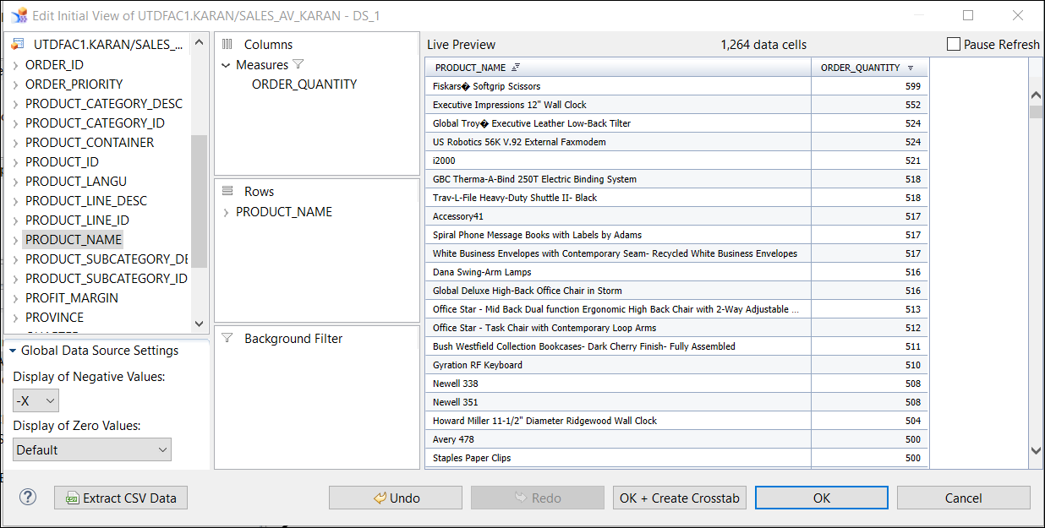

Set the following filters:

Order Priority: Critical

Customer Segment: Corporate

Country Name: United States

Product SubCategory: Computer Peripherals

Click on *OK*.

Save the Application.Execute the Application by clicking on the execute icon and **paste your screeshot here.**

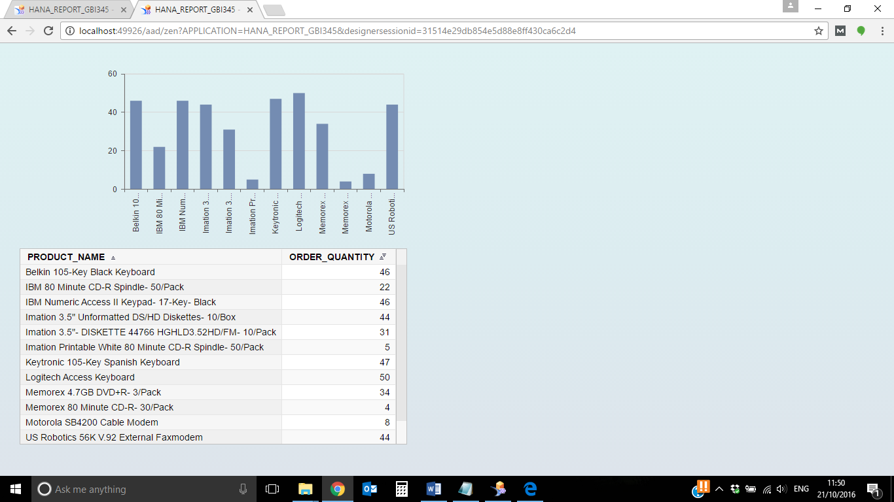

4. Now, let us enhance the appearance of these components by applying some additional properties.

1. To enhance Chart appearance with additional properties,

Click on the chart -> Click on *View* -> click on *Additional Properties*. Additional Properties pane will be diplayed on the right hand side of the sceen.

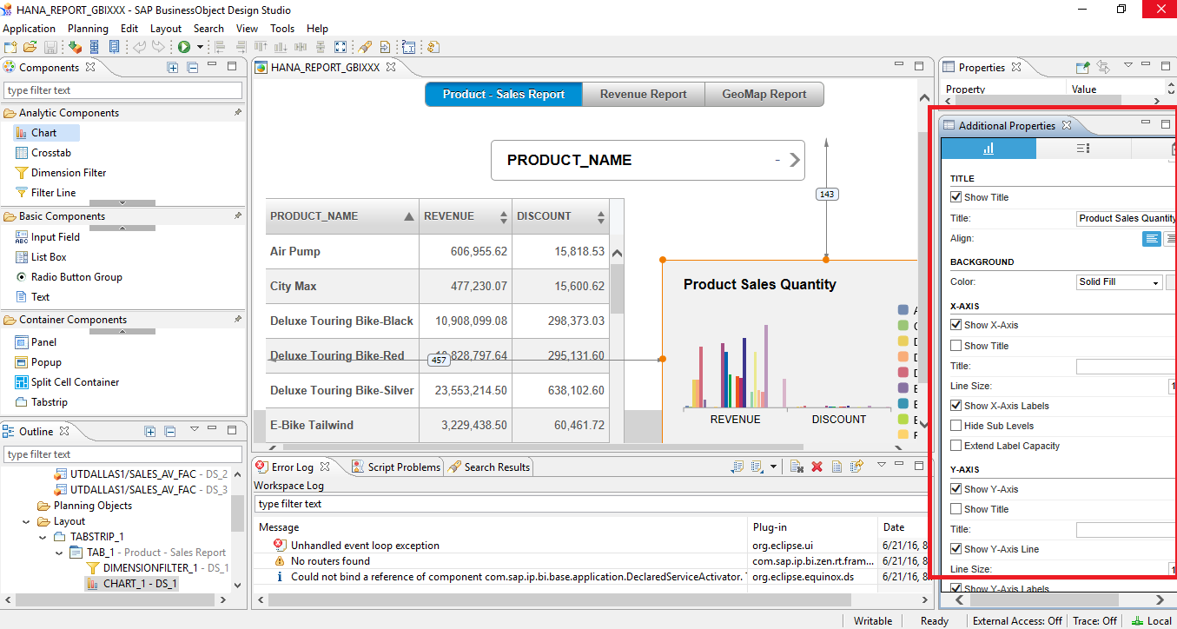

Make the following changes in Additional Properties pane just as given in the screenshots below.

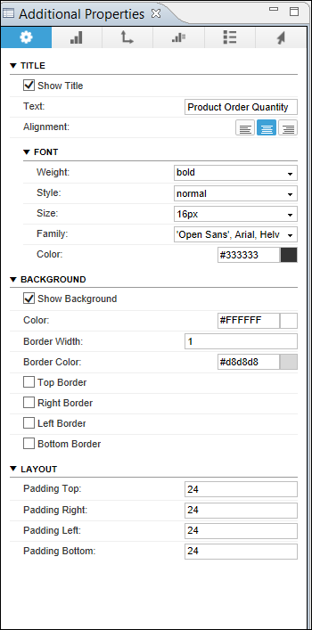

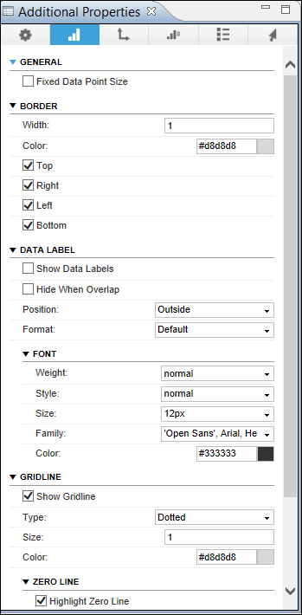

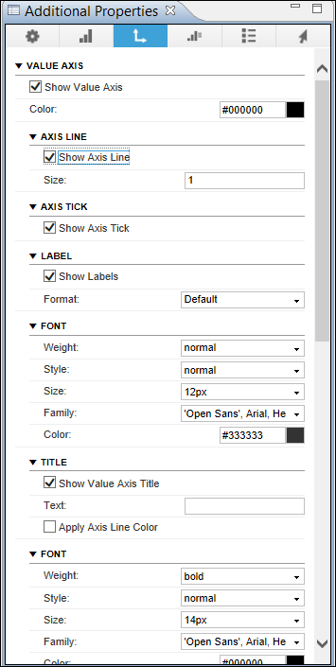

Save the Application, execute it and answer the following questions.

Note : Write the answers and also provide the screenshot for each answer.

(Please make sure that your report name HANA_REPORT_GBIXXX is seen in the screenshot.)

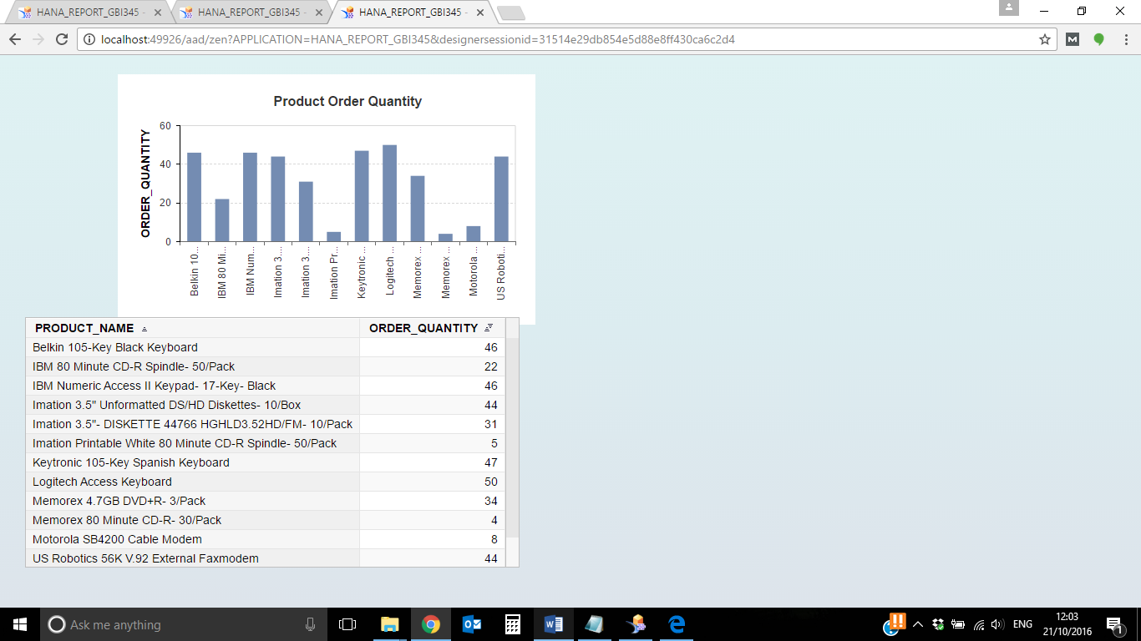

4b. Which product was ordered the most?

**Logitech Access Keyboard: 50**

**Screenshot:**

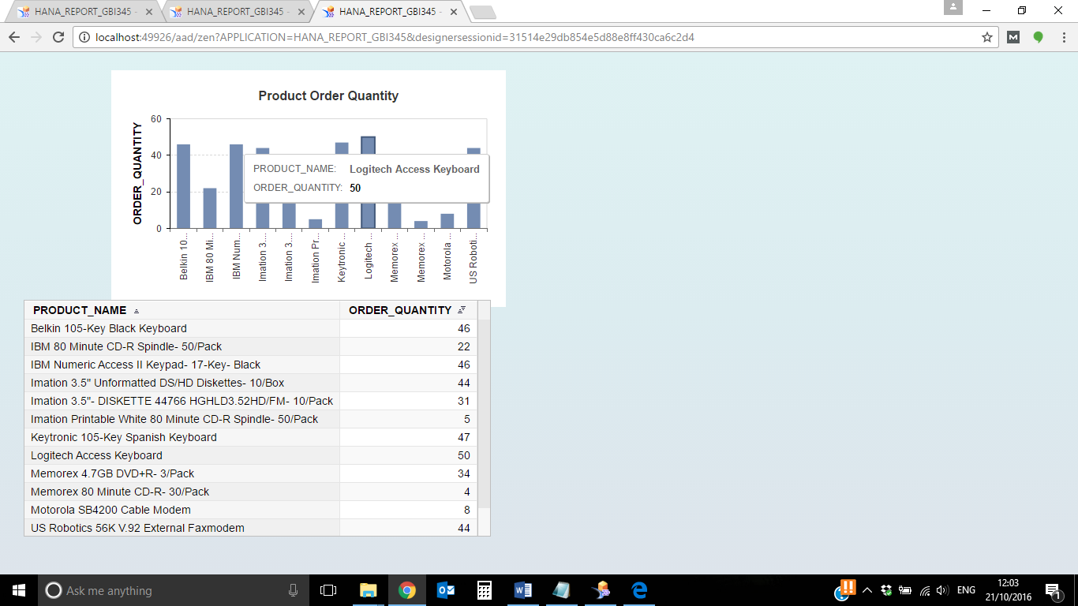

4c. How much is the order quantity for Memorex 4.7GB DVD+R- 3/Pack?

**34**

**Screenshot:**

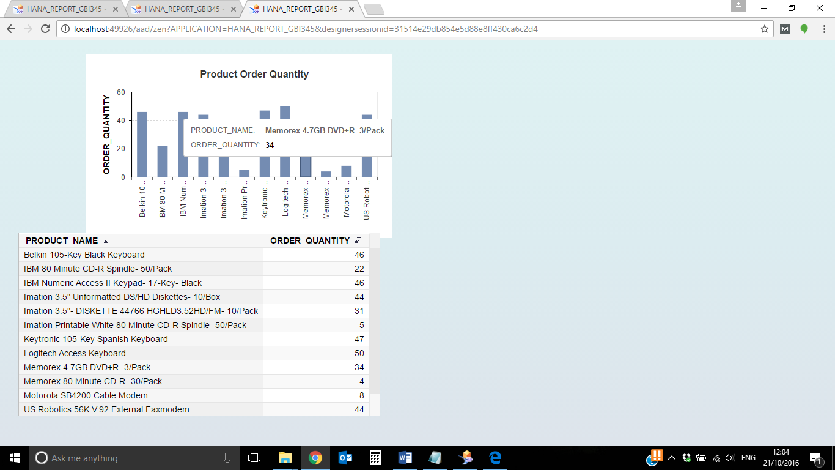

5. Now let us add some new elements to our query.

1. Right click on your Data Source -> Select ‘*Edit Initial View’*. Drag and drop the **Year** dimension onto the Background Filter pane.

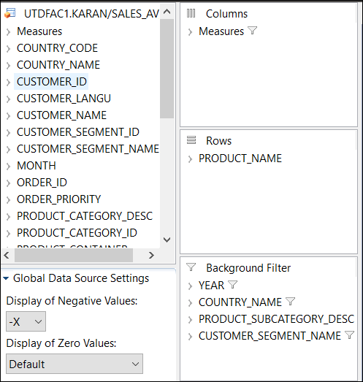

1. Right Click on the Year dimension in the Background Filter pane and select ‘*Filter Members’.*

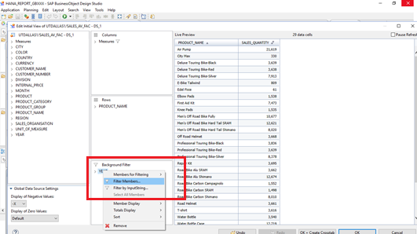

1. Select the year ‘2022’ and then click on *OK.*
2. Similarly, drag the following dimensions and drop them into Background Filters:

Country_Name: United States

Product_SubCategory_Desc: Computer Peripherals

Customer_Segment_Name: Corporate

1. Click Ok again. Save the Application. Execute the Application and answer the following question.

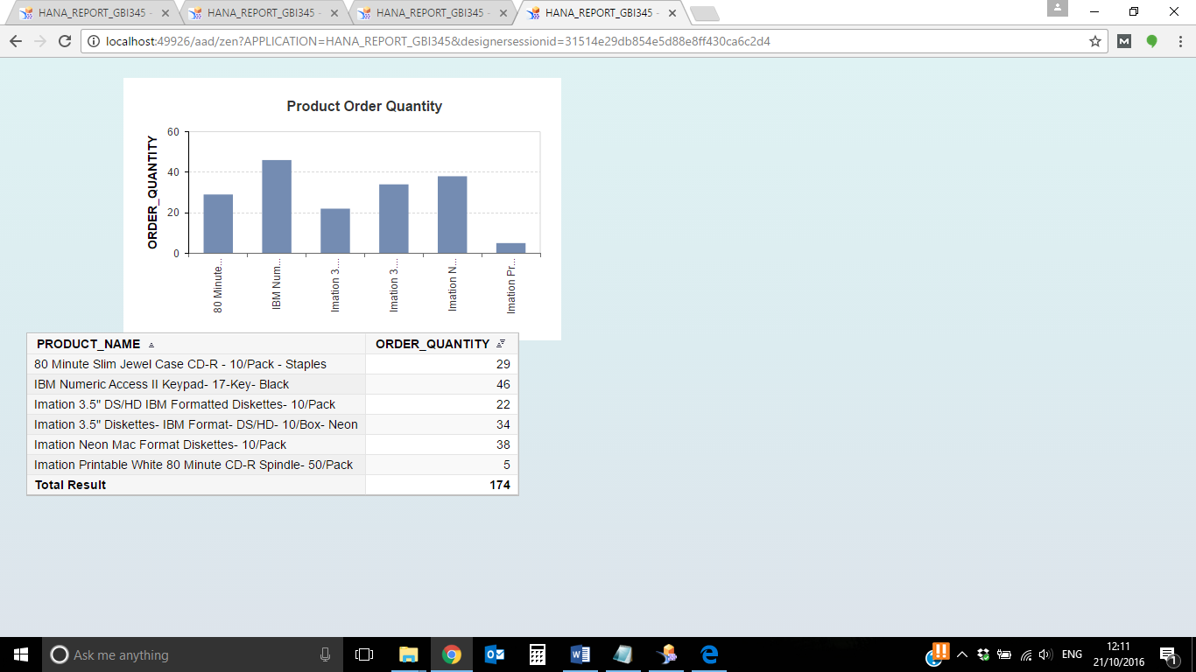

1. Which product was ordered the most in year 2022. (Write down the answer and also paste the screenshot of the report having your report name clearly visible.)

**PRODUCT_NAME: IBM Numeric Access II Keypad-17-Key-Black**

**ORDER_QUANTITY: 46**

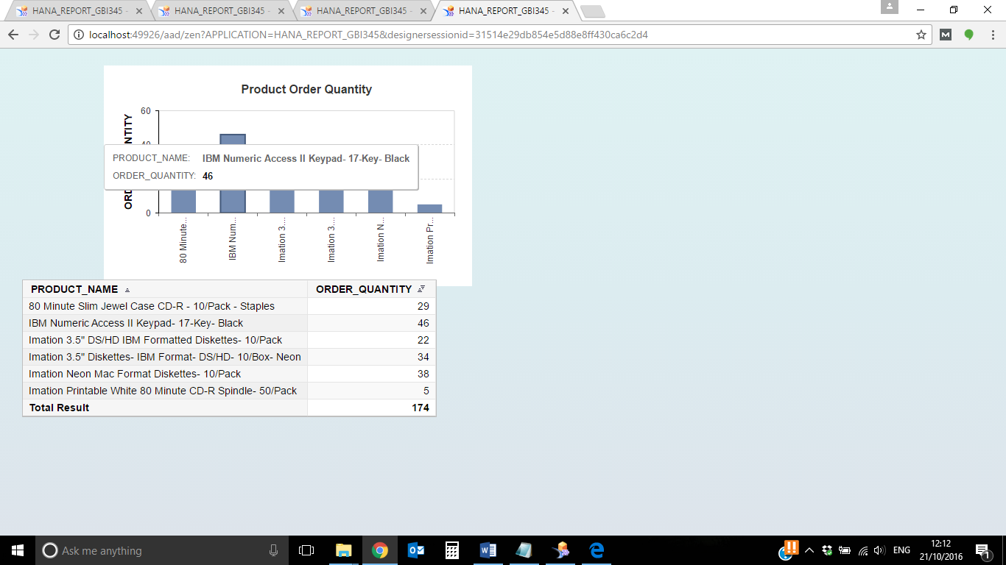

1. Using the ‘*Edit initial view*’ option of the Data Source, remove the background filters that were applied in the previous step. Moreover, add measures **REVENUE** and **DISCOUNT** in the Columns pane instead of SALES_QUANTITY as shown below.

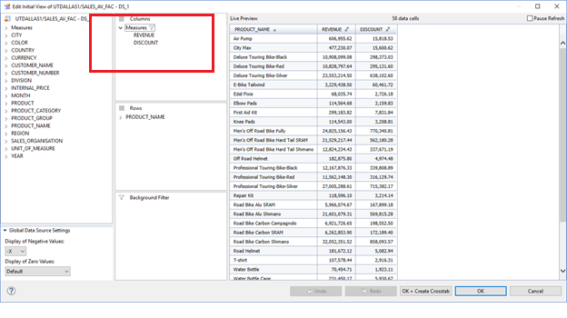

Then click on *OK.*

1. Now as shown below, drag and drop the **Dimension Filter** onto the canvas from Analytic Component section.
2. In Properties pane, under Data Binding, choose the Data Source as **DS_1**. In the same section, choose the Dimension as ‘**PRODUCT_SUBCATEGORY_DESC**’ from the list of dimensions. Under Display section, select Member Display as ‘**Text**’.
3. Click on InfoChart->Properties->Display->Chart Configuration and select Column chart with 2 Y-axis.

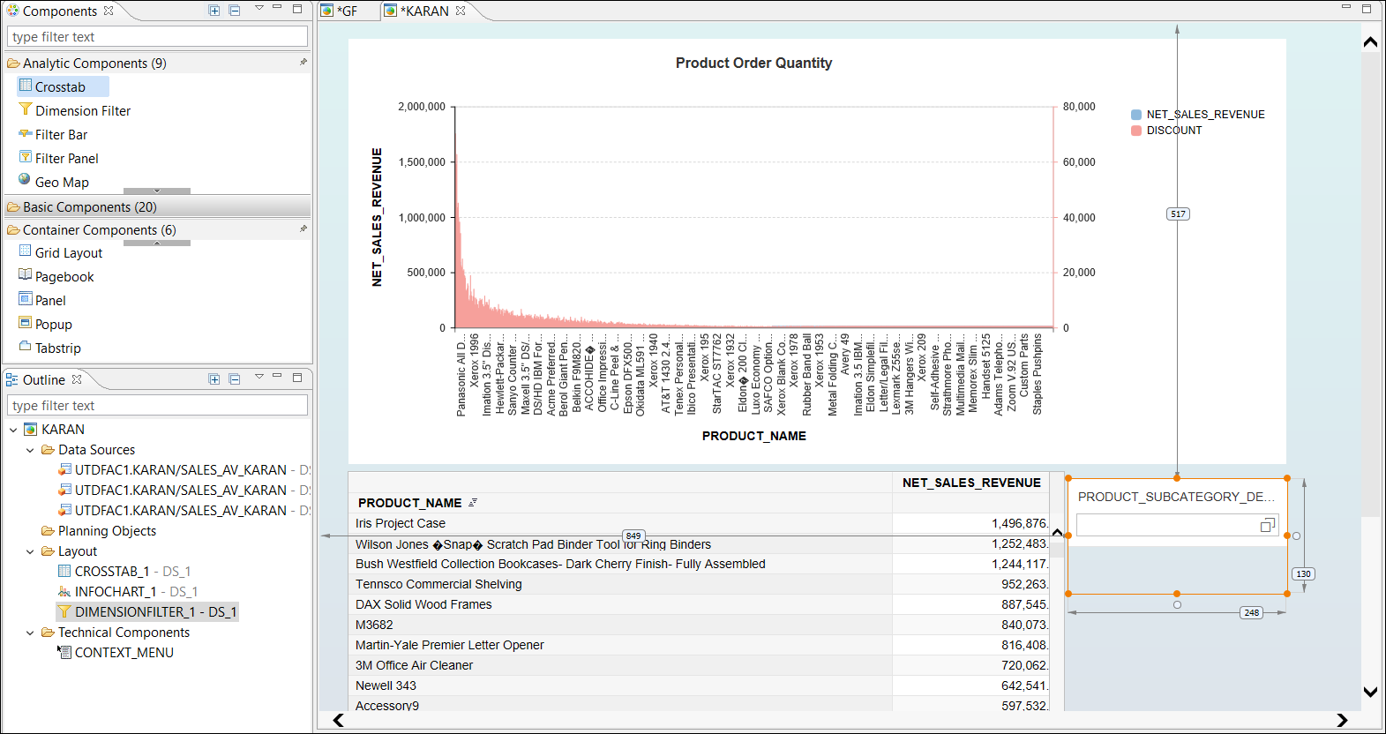

1. Click on *OK*. Save the Application and execute.
2. On the output window, click the PRODUCT_SUBCATEGORY_DESC filter and select **Copiers and Fax**.

Answer the following questions with a screenshot.

1. **Revenue and discount of Sharp AL-1530CS Digital Copier is 104,298.38 USD and 5936.15 USD respectively**

**Screenshot:**

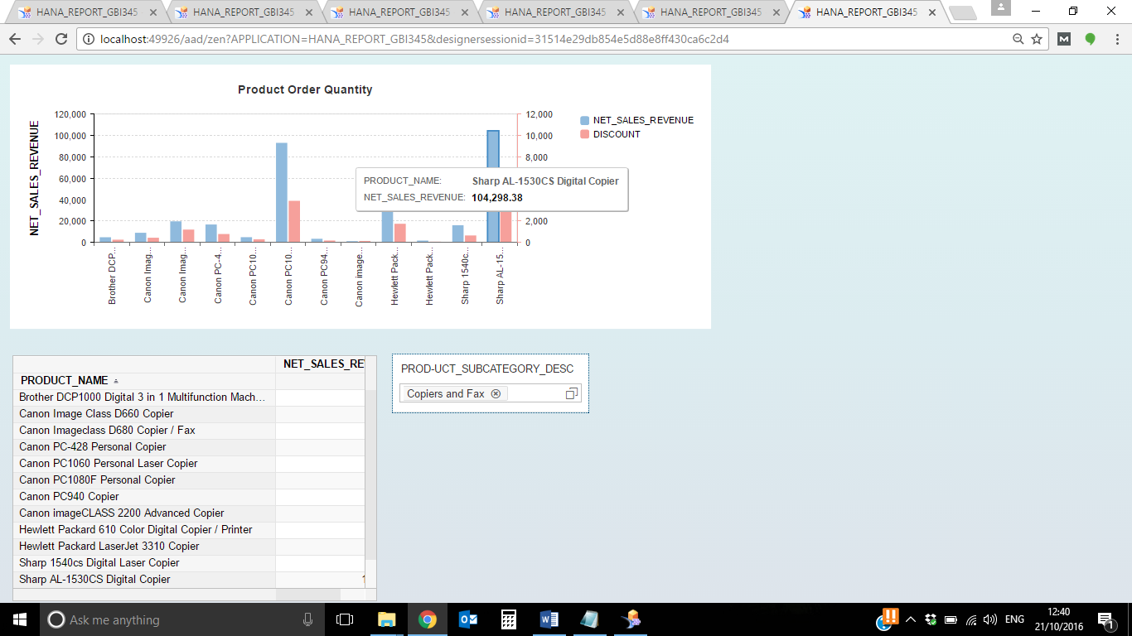

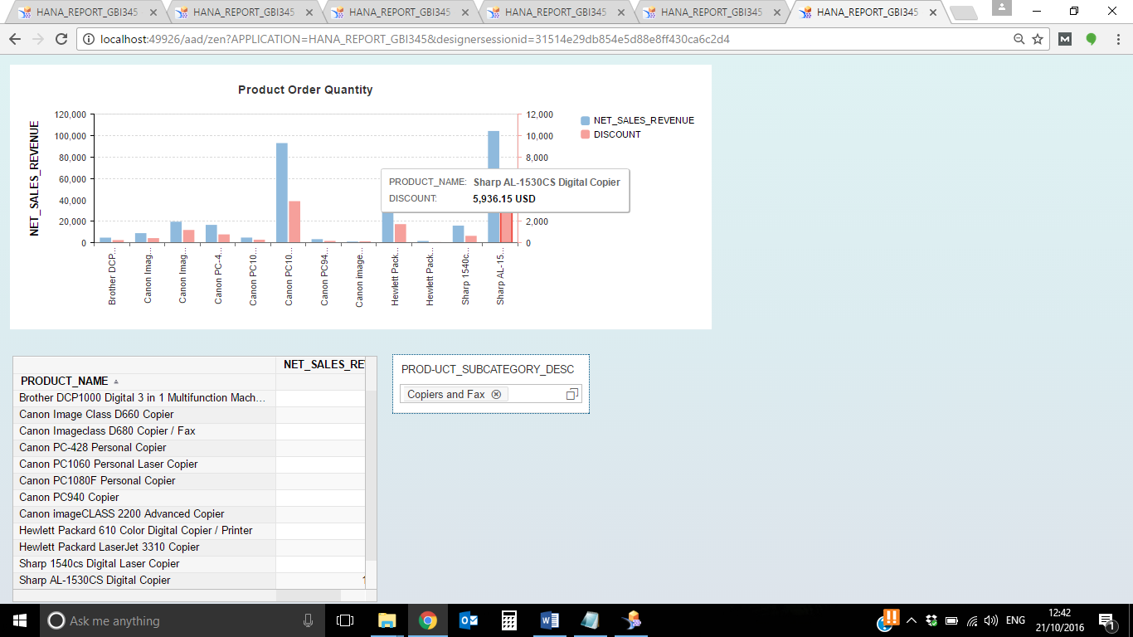

1. Discount for Hewlett Packard 610 Color Digital Copier/Printer is **1,742.64 USD**

**Screenshot:** 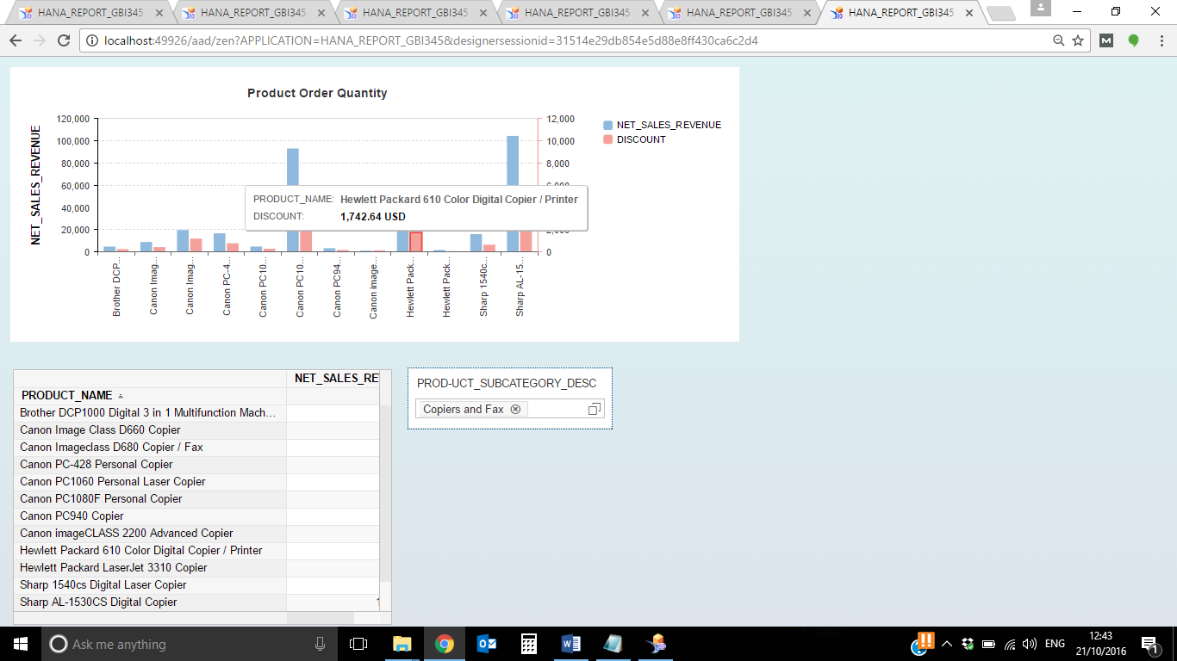

1. Let us add some more components to our Application.
2. Right click on the Data Source in Outline pane -> Click on *Copy*.

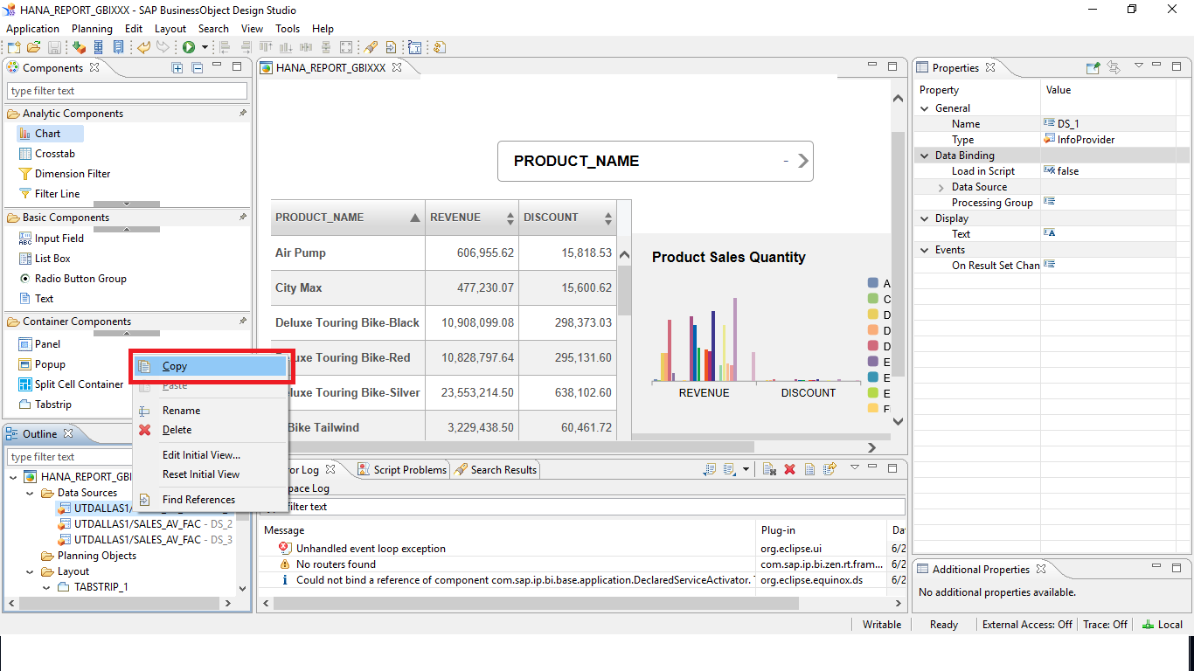

Right click on the Data Source again -> click on *Paste*.

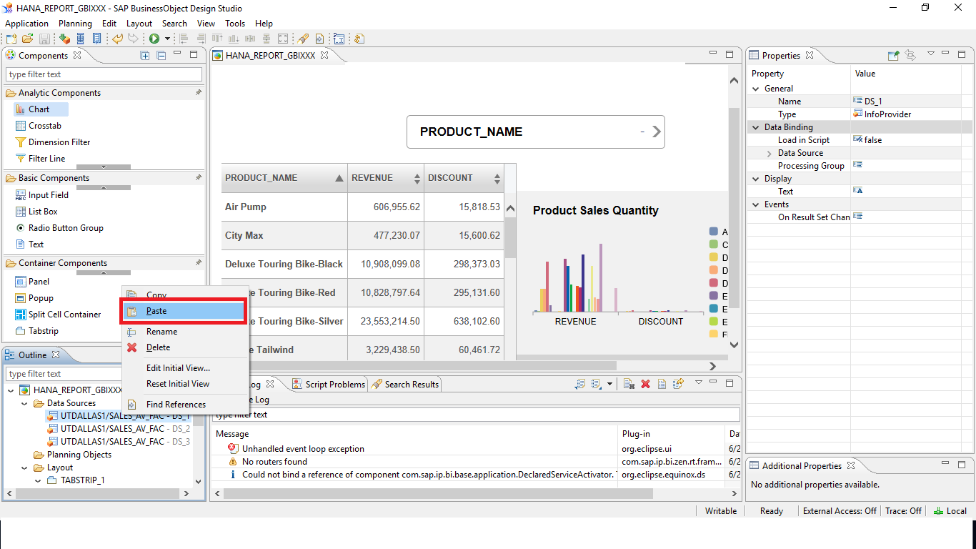

This automatically creates a copy of the existing Data Source with an Alias as DS_2.

1. Right click on **DS_2** and click on ‘*Edit Initial View*’. Put **Net Sales Revenue** and **Region** in Columns, **CUSTOMER_NAME** in Rows and **Country Name** in Background Filters. Then click on *OK.*

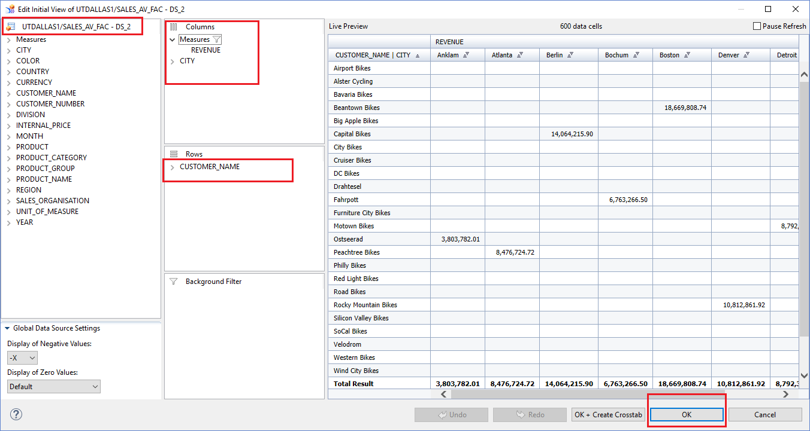

1. Drag & drop a Filter Panel from Analytic Components. Assign DS_2 to it. Then go to the Display section of Properties pane. Select Member Display as ‘**Text**’ and for Dimensions remove everything except for **PRODUCT_SUBCATEGORY_DESC, YEAR and MONTH**.

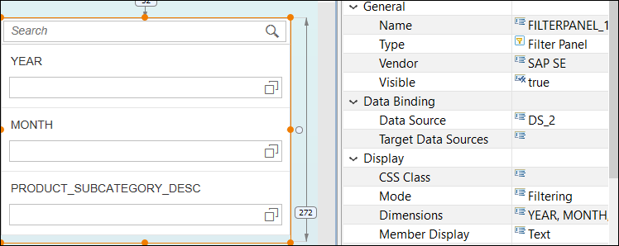

1. Drag & drop another chart onto the canvas and assign DS_2 (the newly created Data Source) to this chart.
2. Go to the Properties pane for this chart and select the Chart Configuration*.* A new window will open. Select Heat Map and click o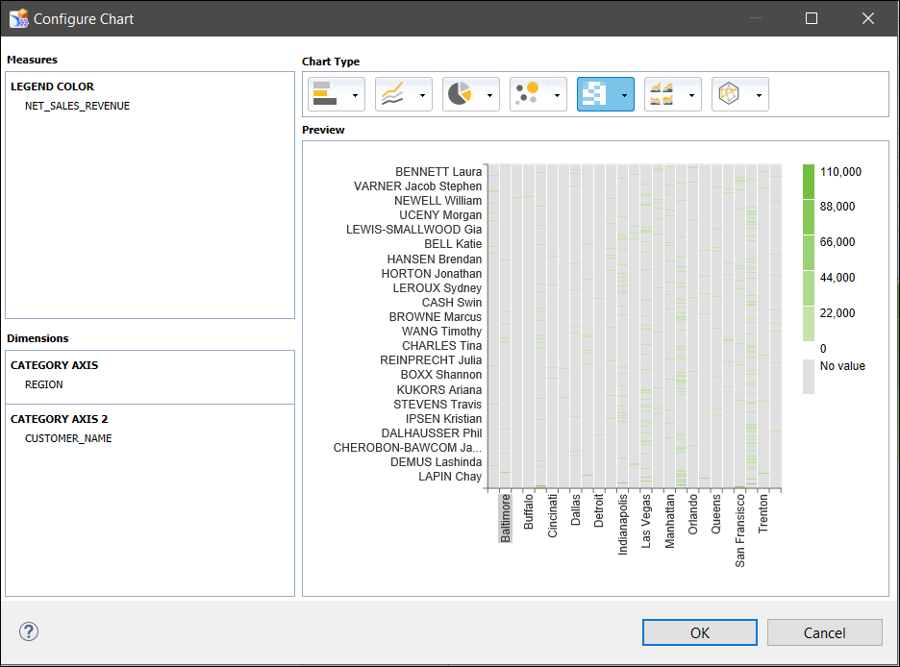

The heat map gets updated onto the canvas.

1. Similarly, drag & drop one more chart onto the canvas and change its ‘Chart type’ to ‘**Bar**’ (Properties pane -> Display section). Also, assign DS_2 to this Bar Chart as shown.

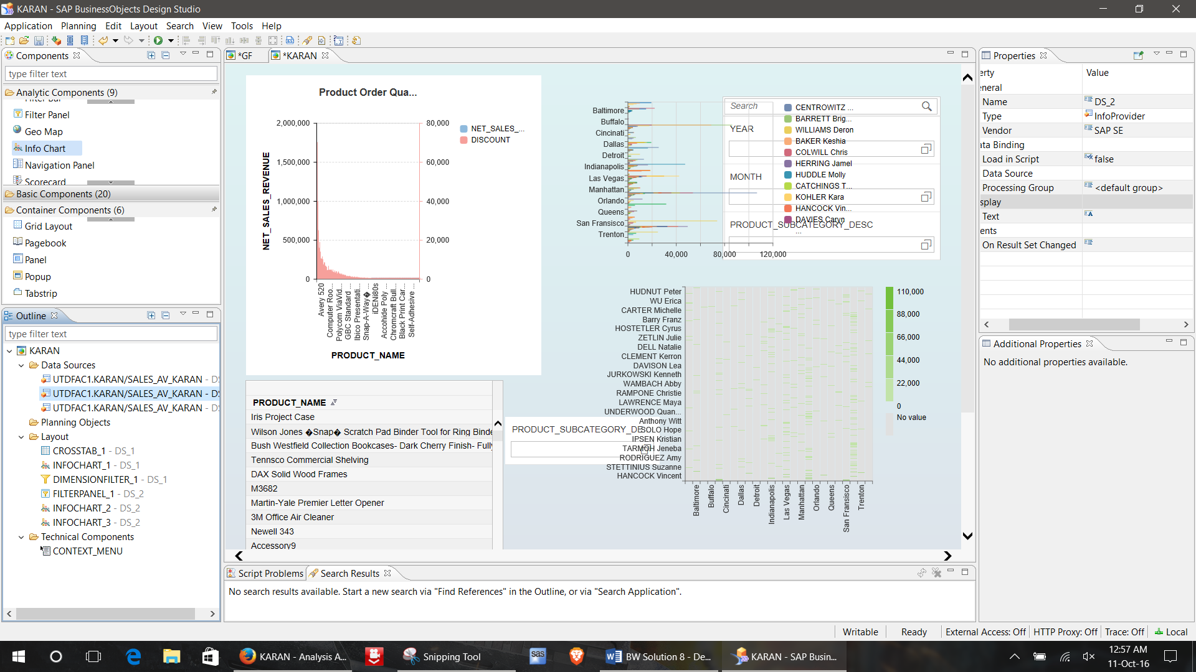

1. Save the changes.
2. Now, let us group these components logically into different tabs.
3. Click on **Tabstrip** from Container components and drag it onto the canvas.

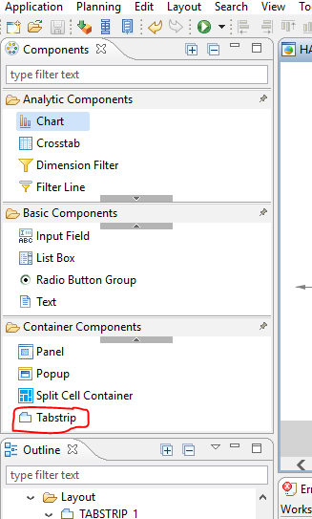

Once you do that, the Tabstrip will be visible in the Outline pane with 2 default Tabs.

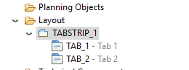

1. Drag DIMENSIONFILTER_1, CHART_1 and CROSSTAB_1 one by one into TAB_1.
2. Now click on **TAB_1** and change its Text (Properties pane) to ‘**Product - Sales Report**’.
3. Similarly, drag FILTERPANEL_1, CHART_2 and CHART_3 one by one into TAB_2.
4. Click on **TAB_2** and change its Text (Properties pane) to ‘**Revenue Report**’.
5. Rearrange/adjust the components in each tab such that they are placed correctly and will be fully visible once you execute the Application.

Your canvas should now look like this.

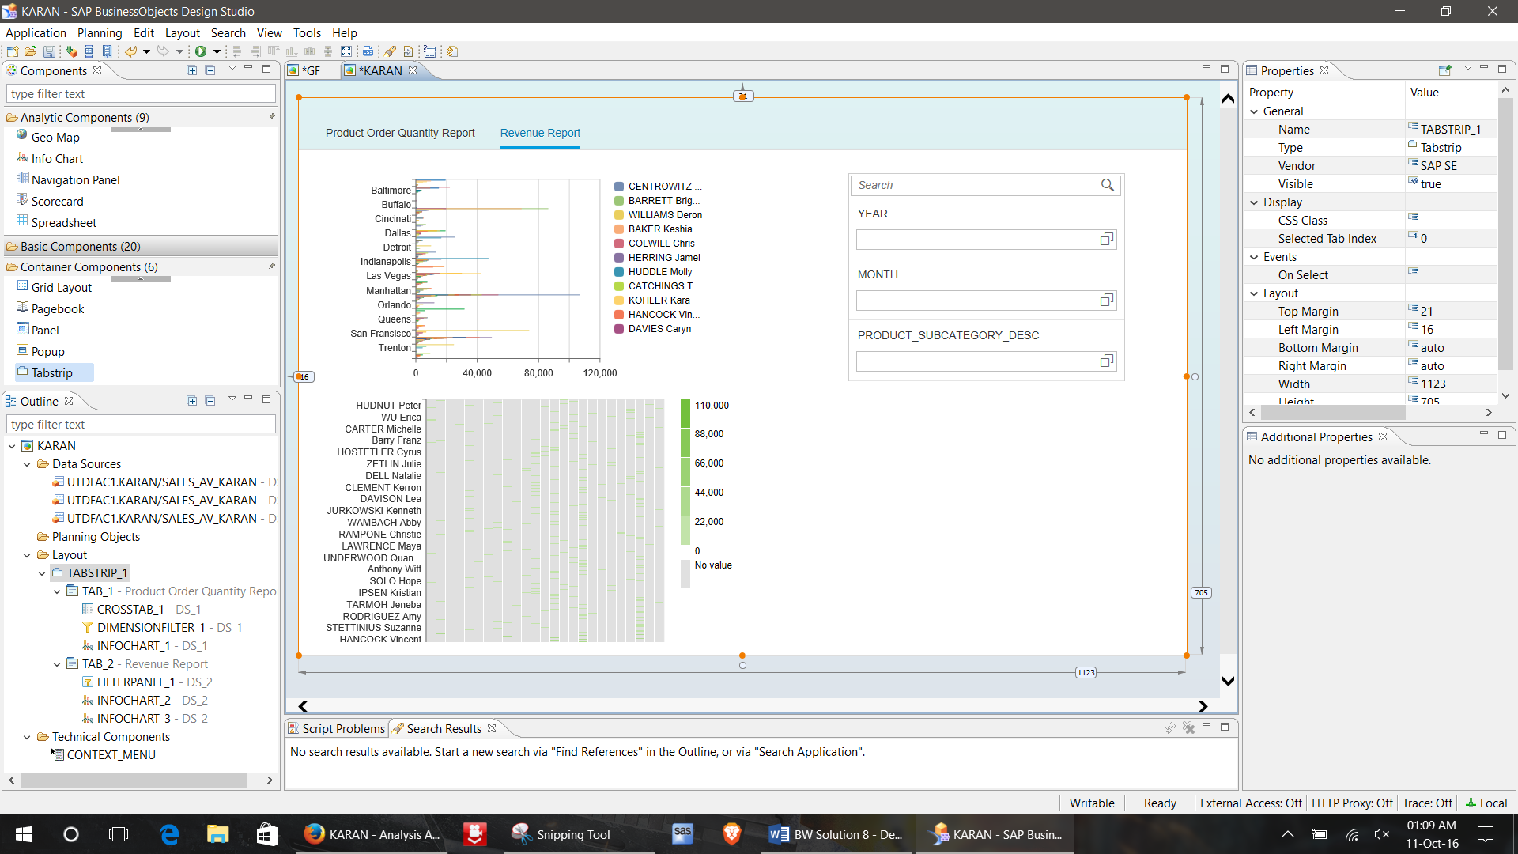

1. Execute the Application. In the output screen, go to the **Revenue Report** tab and answer the following questions. Also, **paste the screenshot** of the output screen **for each answer** (after applying the filters).
2. Set PRODUCt_SUBCATEGORY_DESC to Appliances and year to 2024.Which region has the highest revenue?

**LAS VEGAS**

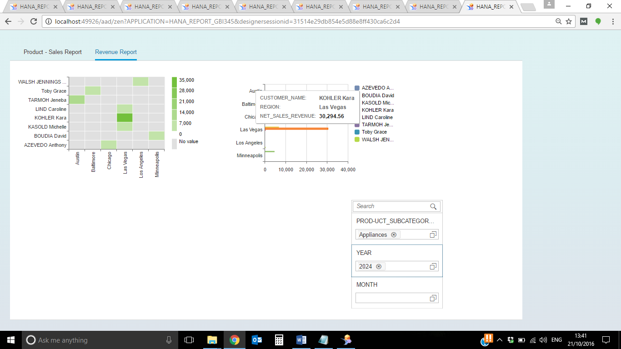

1. Revenue for Toby Grace?

**1,075.93**

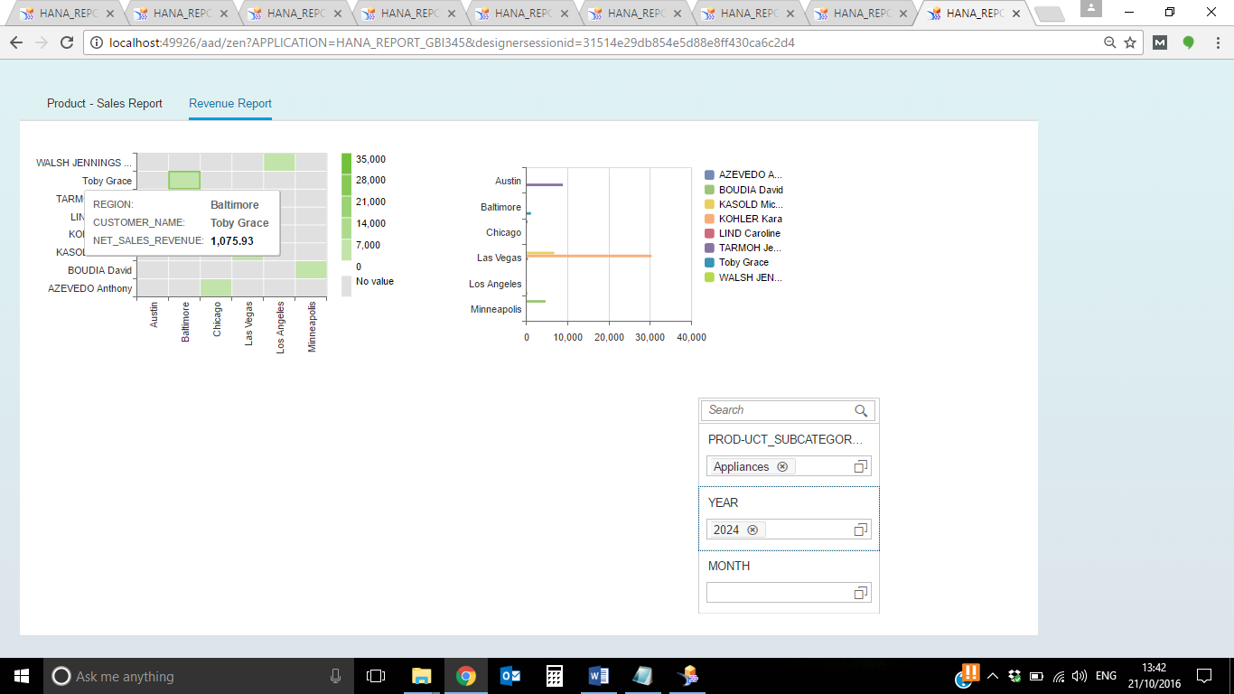

1. In year 2021, which customer and region generated the least revenue? (Hint: Use the filter panel for making the appropriate selections.)

**Region: Kansas City**

**Customer: ANDERSON Haley**

**Revenue: 289.38**

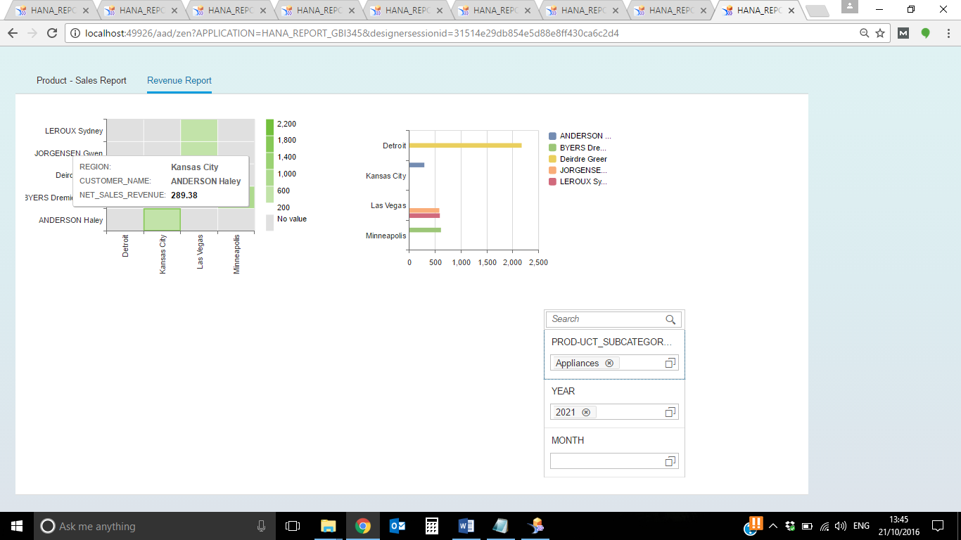

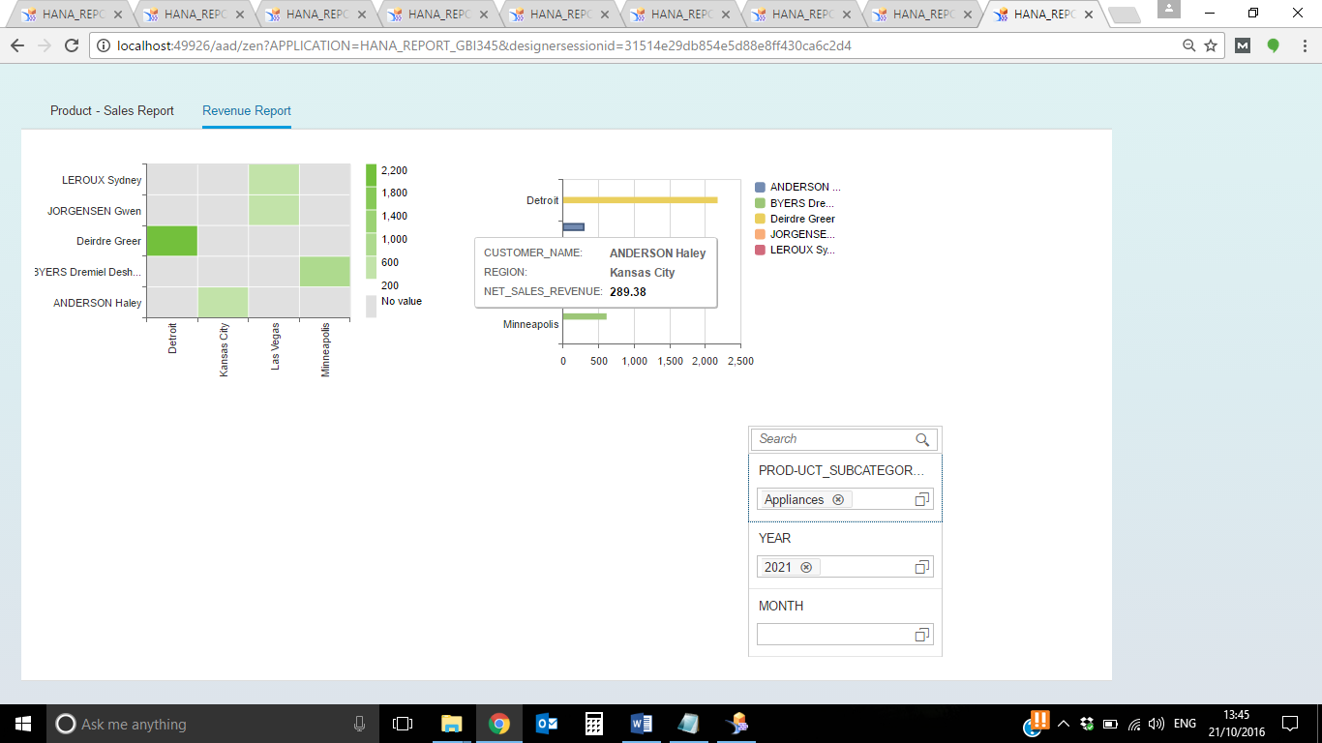

1. Set the PRODUCT_SUBCATEGORY_DESC to Telephones and Communications.In the first half of 2021, which customers have similar revenues?

**GIBB Jacob(119.00), HARPER Dawn(120.32) have similar revenues**

**UHL Lisa(126.78), BANKS David(127.18) have similar revenues**

**SCOTT Coleman(292.87) and Odella Nelson(290.24) have similar revenues**

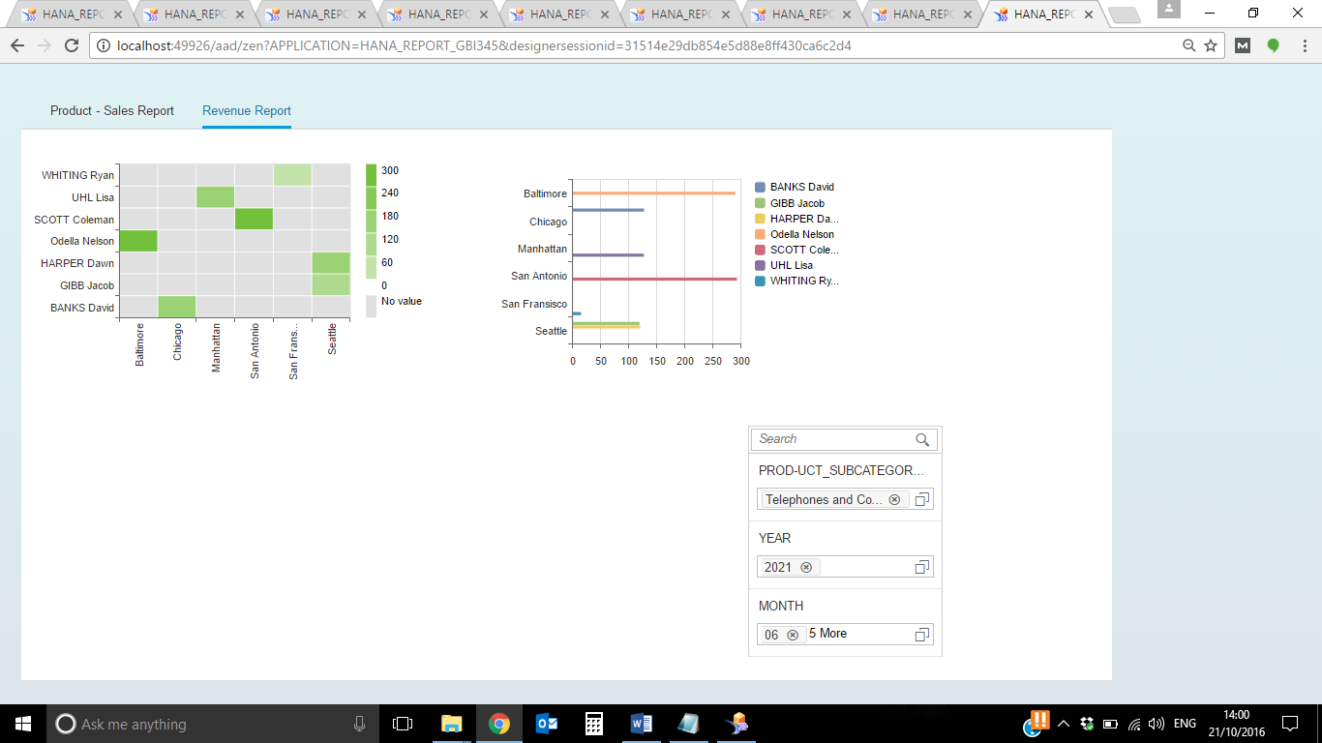

1. In second half of 2021 who are your top 3 customers?

**Top 3 customers are as follows:**

**1. HOOKER Destinee – 1105.92**

**2. SYMMONDS Nick – 1047.13**

**3. CESAN Michelle - 1021.16**

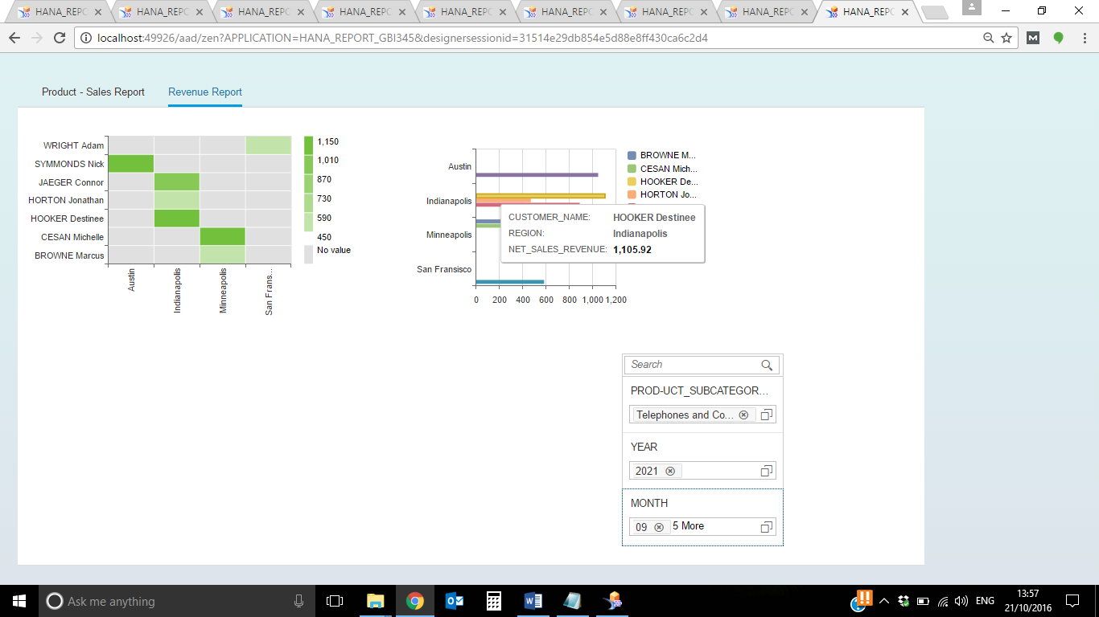

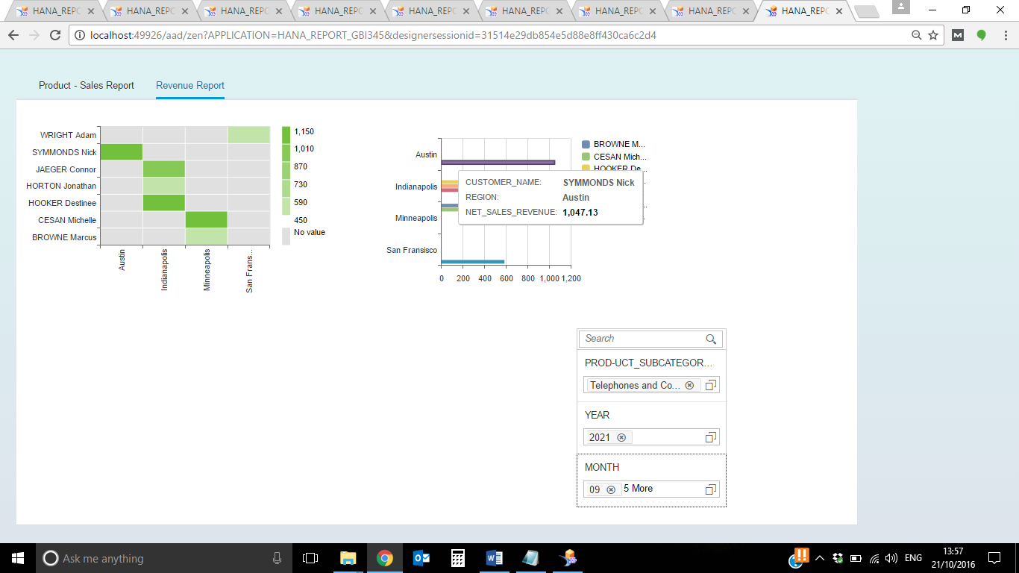

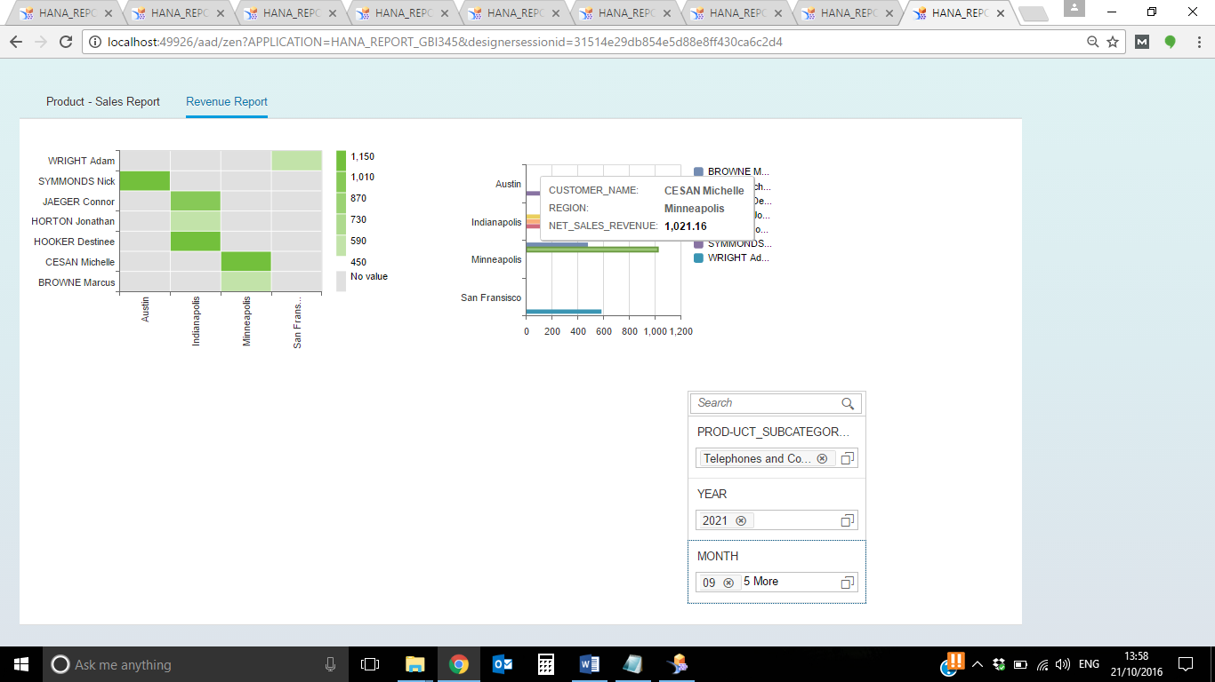

1. Now we need to add one tab into the current Tabstrip.
2. In Design studio right click on TABSTRIP_1 (Outline pane) and create child tab

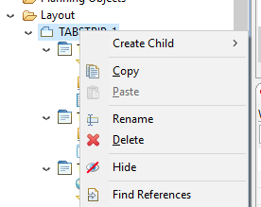

1. Name it as ‘Geo Map Report’ (in text properties)

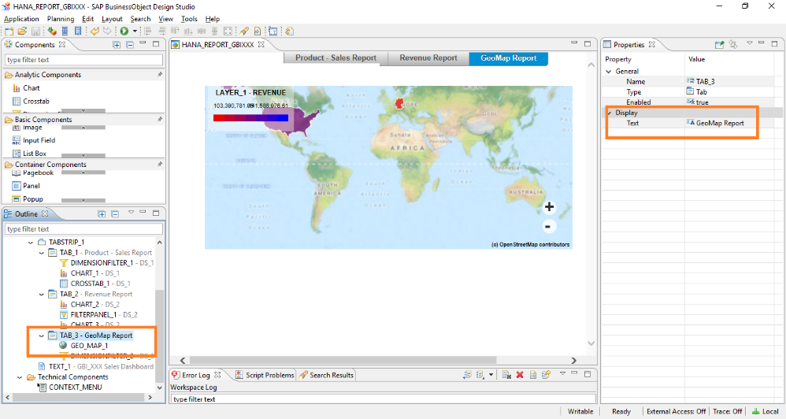

1. Create a copy of the existing Data Source (you can choose either DS_1 or DS_2 to copy from) the way you created in step 6. This copy will have an alias as DS_3.
2. Right click on DS_3 and click on ‘*Edit Initial View’*. Put Net_Sales_Revenue in Columns; COUNTRY_NAME in rows and click on OK.

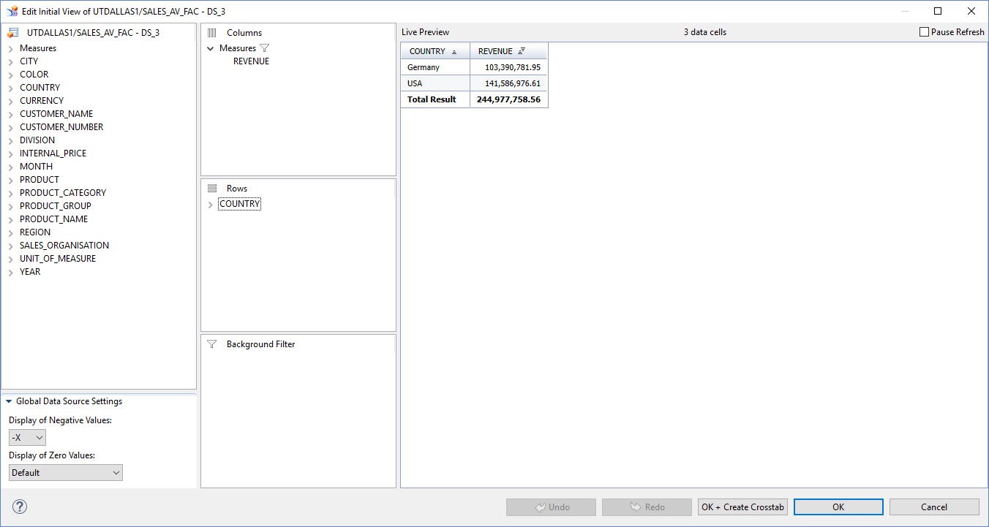

1. Drag Geo Maps from analytic components and drop it on canvas. In the Additional Properties pane for Geo Map, select Data Source as DS_3, Measure as Net_Sales_Revenue, Start and End Color. Note that the Start color would represent the lowest revenue while the End represent highest revenue.

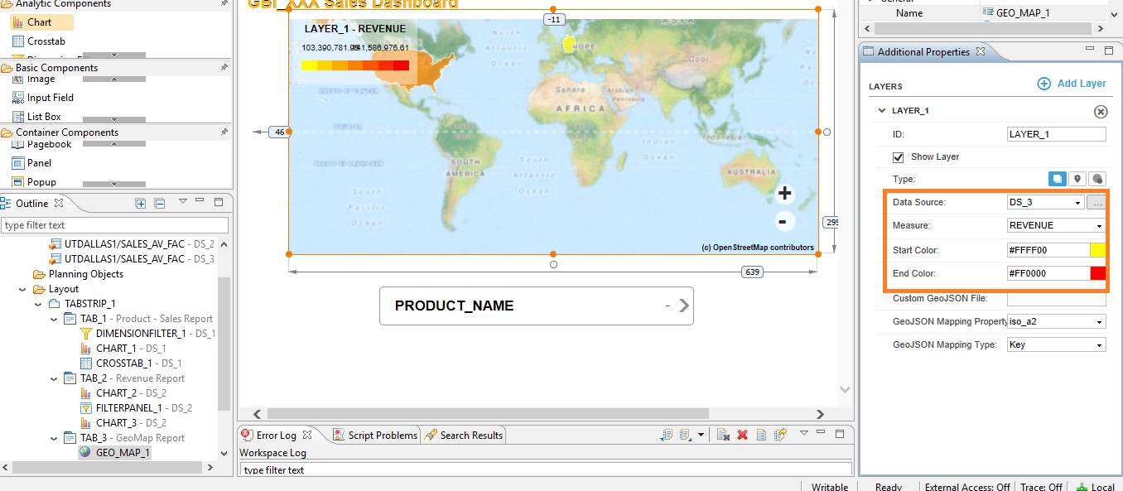

1. Now your canvas should look like this.

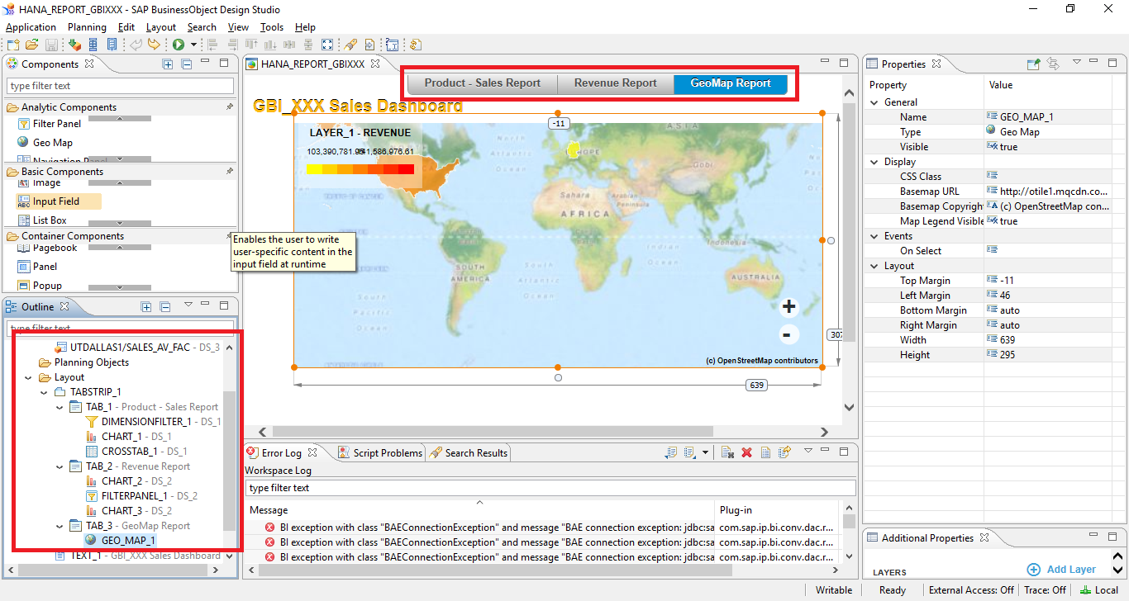

Save the Application and Execute.

1. **Name the top 3 countries** by revenue. Also, **paste the screenshot**.

Top 3 countries by revenue are as follows:

**1. China – 3,086,382.24**

**2. UK – 2,978,720.89**

**3. America – 2,505,789.31**

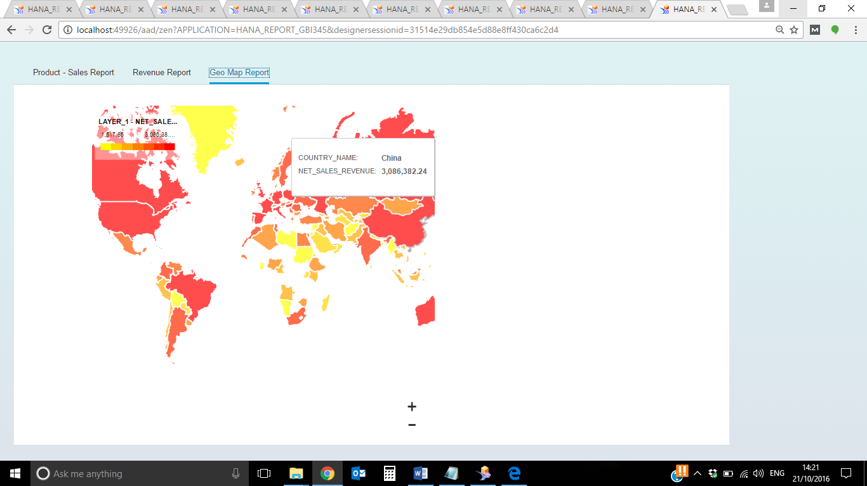

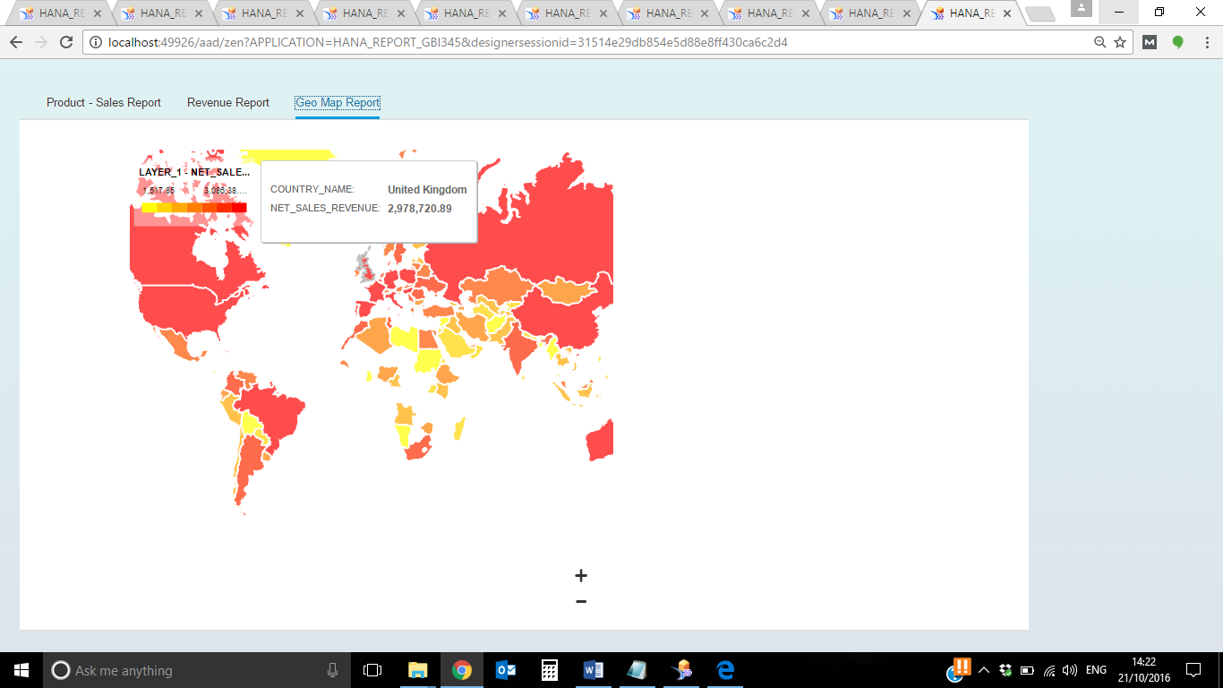

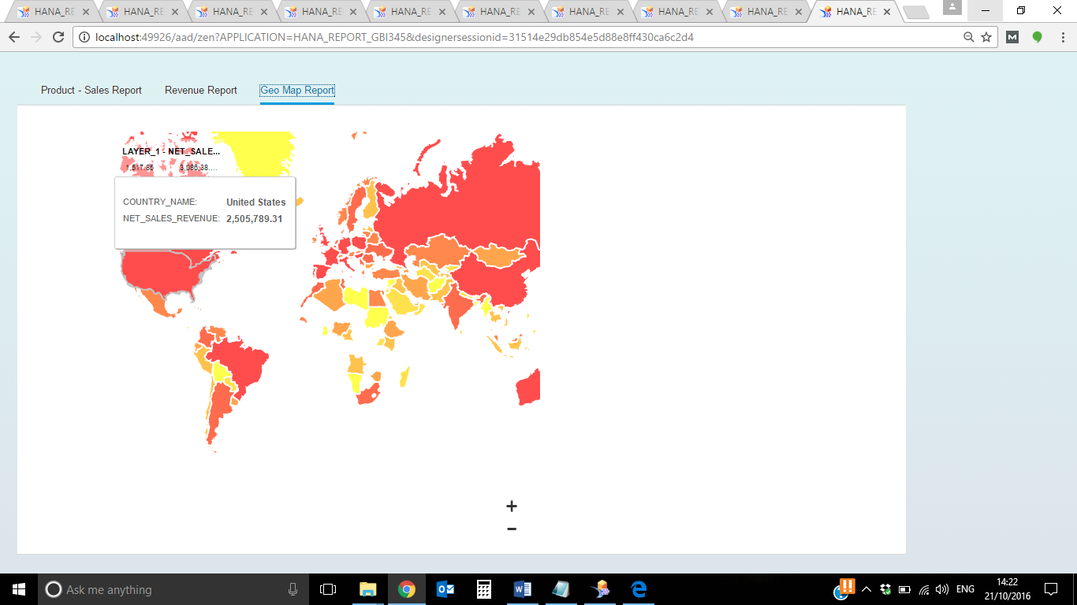

1. Finally, now let us give a heading to our dashboard report. Drag and drop a ‘text’ from the Basic Component section and place it in the heading of the canvas. Write ‘**GBI_XXX Sales Dashboard**’ inside it.

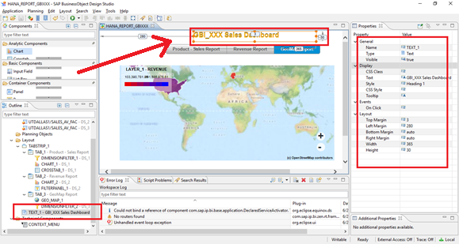

Click on Save. Execute the Application and paste output screenshot of each of the tabs below.

Tab 1: Product-Order Quantity Report

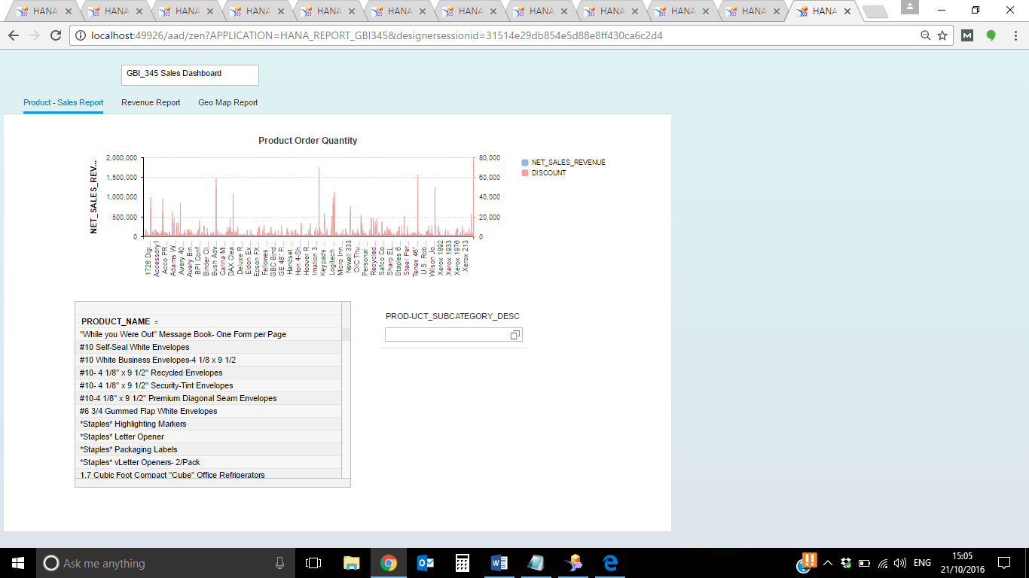

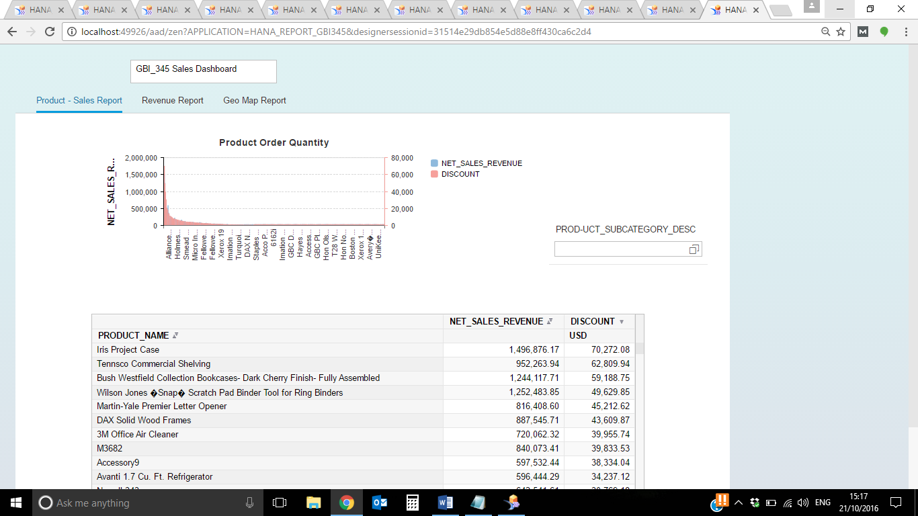

Tab 2: Revenue Report

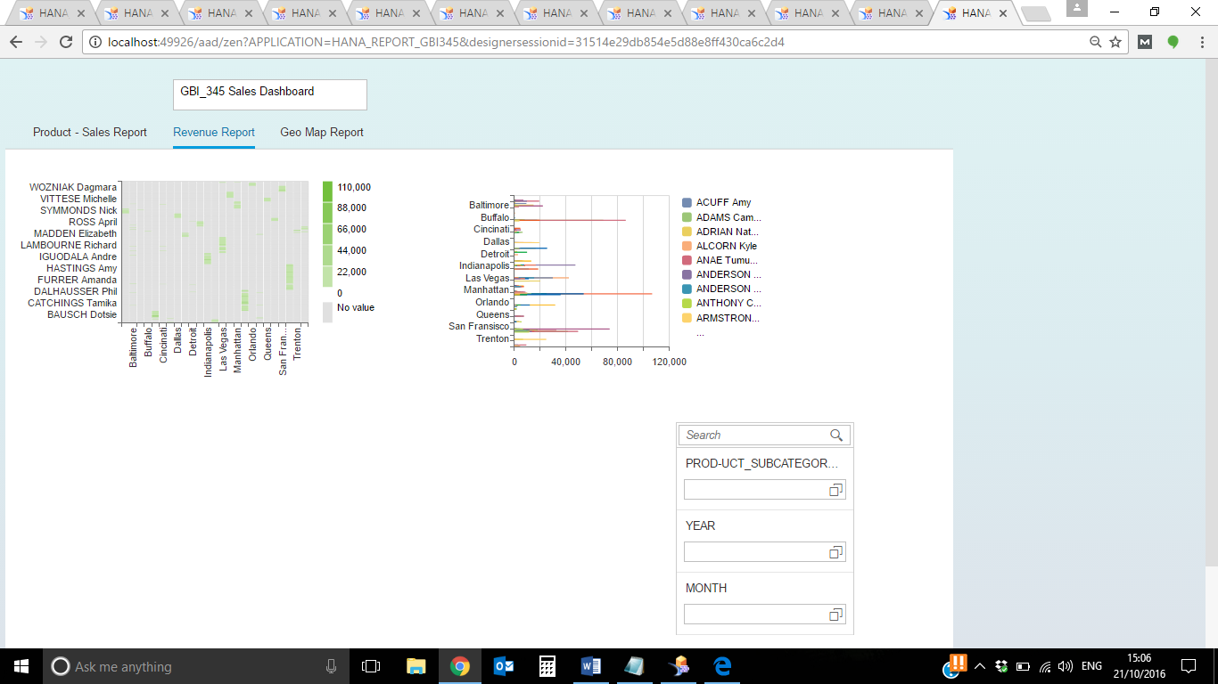

Tab 3: Geo Map Report

